Unit 5 Automoblox T9 Dimensioned Drawings

The following drawings are provided for information only to be used with Activity 5.2 Making Sketches in CAD and Activity 5.5 CAD Model Features and are not intended to provide complete details. Only partial dimensions for some of the T9 Automoblox model components are given in order to provide the measurements necessary to complete Activities 5.2 and 5.5 when the physical models are not available.

PASSENGER BASE
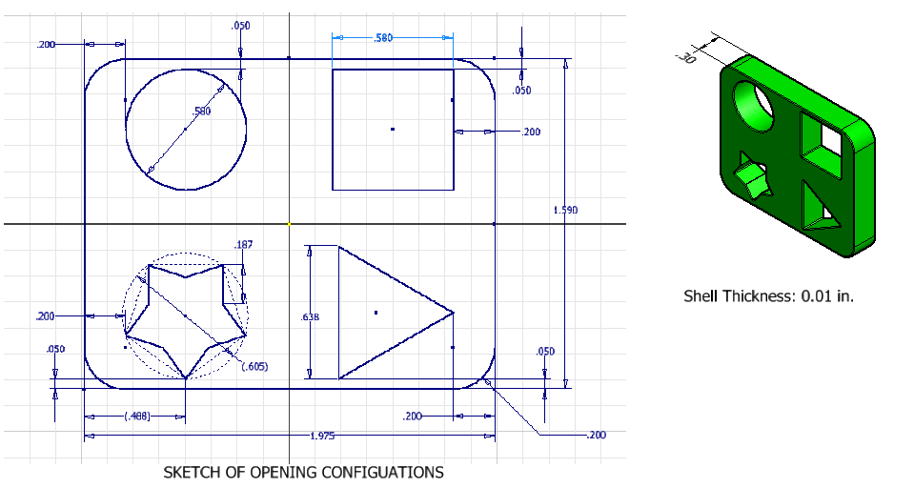

PASSENGER SECTION
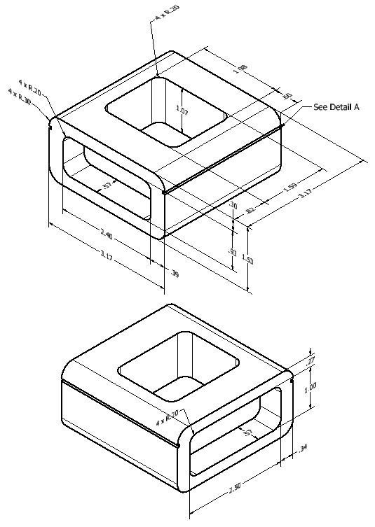 | 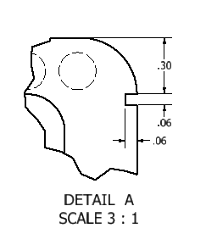

FRONT
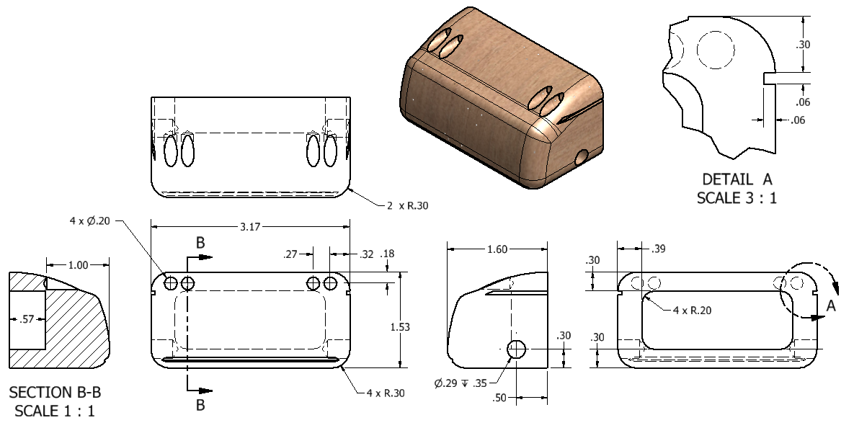

WINDSHIELD
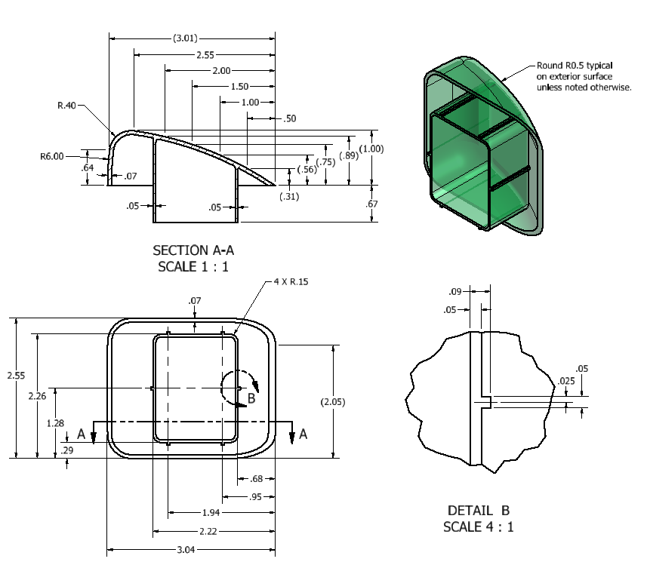

CONNECTOR
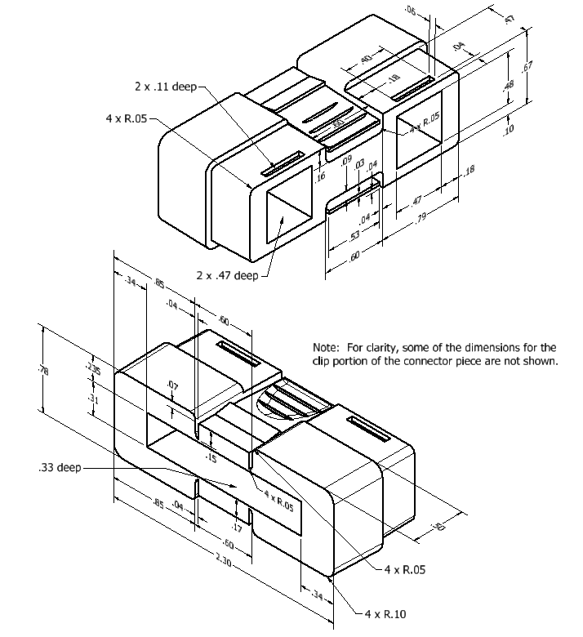

AXLE

