1. | Generating a large quantity of ideas for a solution to a problem is called __________.
 | A. | Constraining | C. | Ideation
 | B. | Brainstorming | D. | Implementation
2.
  The image at the right is an example of ________________. | 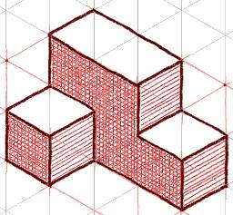
 | A. | Airbrushing | C. | Tonal shading
 | B. | Highlights and shadows | D. | Coloring
3. | The image in question #2 is an example of what type of pictorial drawing?
 | A. | Isometric | C. | 1 point perspective
 | B. | Oblique | D. | 2 point perspective
4.
  What type of pictorial drawing is pictured to the right? | 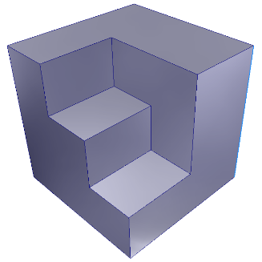
 | A. | Isometric | C. | Perspective
 | B. | Oblique | D. | Orthographic
5.
  What type of pictorial drawing is pictured to the right? | 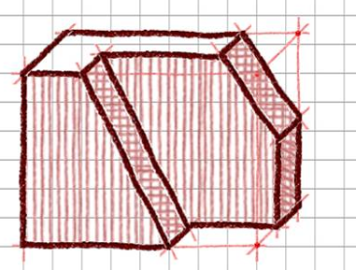
 | A. | Isometric | C. | 1 point perspective
 | B. | Oblique | D. | 2 point perspective

6.
  What type of drawing/view best describes the image to the right? | 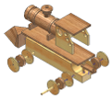
 | A. | Multiview | C. | Exploded
 | B. | Orthographic | D. | Assembly

7.
  What type of drawing/view best describes the image to the right? | 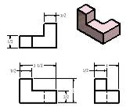
 | A. | Assembly presentation drawing |  | C. | Section view
 | B. | Exploded view |  | D. | Detail drawing
8.
  The image to the right is an example of a(n) ________________. | 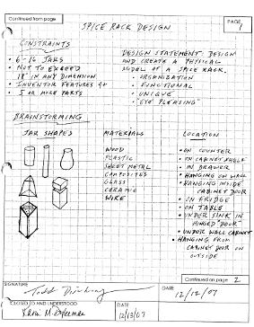
 | A. | Project portfolio |  | C. | Engineer’s notebook
 | B. | Design brief |  | D. | Technical report
9. | Engineers create _________________ to quickly record, communicate, and investigate ideas.
 | A. | 3D models | C. |  | Sketches
 | B. | Technical drawings | D. |  | Animations

10. | The most common view used in three-view, orthographic drawings are _________________.
 | A. | Front, top, left side | C. | Top, front, bottom
 | B. | Front, left side, right side | D. | Front, top, right side

11. | What term best describes the list of items below?  - Must be made out of 4 to 6 pieces  - Must be “interlocking”  - Part cannot extend more than 3 units in any direction  - No two parts can be the same
 | A. | Client | C. | Constraints
 | B. | Deliverables | D. | Problem statement

12. | A full-scale working model used to test a design concept is called a(n)
 | A. | Prototype | C. | Mock up
 | B. | Scale model | D. | Conceptual model
13. | What image below best represents a working drawing?
 | A. | 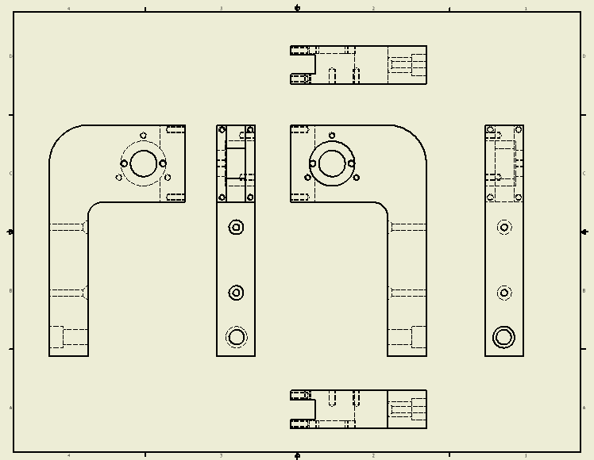 | C. | 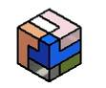
 | B. | 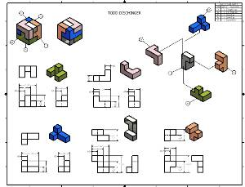 | D. | 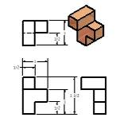
14. | An improvement of an existing technological product, system, or method is referred to as a(n)
 | A. | Invention | C. | Serendipitous event
 | B. | Innovation | D. | Technological change

15.
  A(n) _____________ sketch is a sketch with text added to enhance the communication of the ideas/thoughts of the designer. | 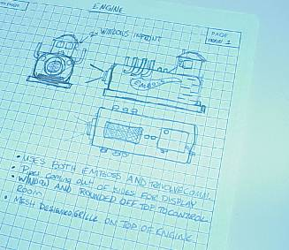
 | A. | Thumbnail | C. | Documented
 | B. | Preliminary | D. | Annotated
16. | A(n) _______________________ is the most common method of communicating the shape and size of an object that is intended for manufacture.
 | A. | Multi view projection | C. | Auxiliary view
 | B. | Exploded view | D. | Pictorial view

17. | The basic dimension on a detail drawing that indicates the distance from front to back.
 | A. | Width | C. | Depth
 | B. | Height | D. | Length

18. | Which is the first view placed or created in a three-view drawing or sketch?
 | A. | Right side | C. | Front
 | B. | Top | D. | Left side
19.
  What are the part indicators called on this image? | 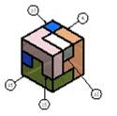
 | A. | Nodes | C. | Bubbles
 | B. | Balloons | D. | Encircled labels
20.
  What is the name of the item pictured to the right that is commonly found on a drawing sheet? | 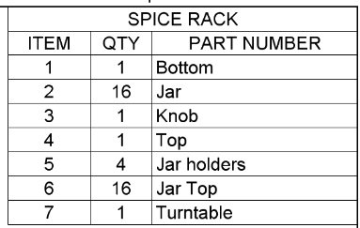
 | A. | Specification sheet | C. | Histogram
 | B. | Title block | D. | Parts list
21.
  What is the name of the item pictured to the right that is commonly found on a drawing sheet? | 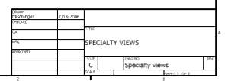
 | A. | Parts list | C. | BOM - bill of materials
 | B. | Heading | D. | Title block
22. | Never dimension to a(n)
 | A. | Hidden line | C. | Centerline
 | B. | Center mark | D. | Object line
23. | The first part brought into an assembly is known as the base component. The base component is
 | A. | Flexible | C. | Non grounded
 | B. | Adaptive | D. | Grounded
24. | A(n) ________________ is a person who is trained in and uses technological and scientific knowledge to solve practical problems.
 | A. | Craftsperson | C. | Engineer
 | B. | Technician | D. | Scientist

25. | The organization that sets the standards for drawing symbols, line conventions, and dimensioning practices is know as
 | A. | OSHA | C. | ANSI
 | B. | NAFTA | D. | AAA

26.
  The precision measuring tool pictured to the right is called a(n) ________________________. | 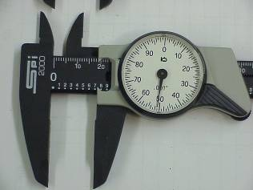
 | A. | Engineer’s scale | C. | Digital micrometer
 | B. | Dial caliper | D. | Scientific ruler

27. | The images pictured below are best described as _______________.  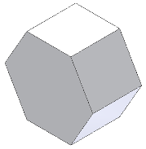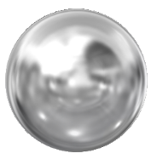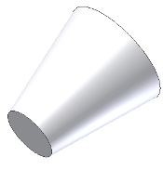
 | A. | Shapes | C. | Regular polygons
 | B. | Forms | D. | Extrusions

28.
  All of the icons pictured to the right represent ______________ constraints and can be used to define the shape and size of sketched geometry in a CAD system. | 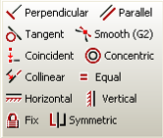
 | A. | Assembly | C. | Design
 | B. | Numeric | D. | Geometric
29. | Study the steps used to create the solid model below. What method did the designer use to create this part?  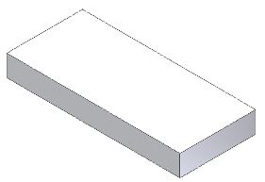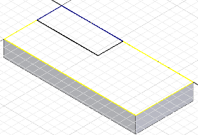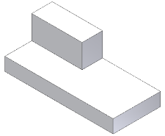
 | A. | Additive | C. | Subtractive
 | B. | Skeletal | D. | Assembly
30. | If a designer/engineer needs to calculate how many quarts of paint are needed to double coat 500 of one particular part in an assembly, what physical property would they need to know?
 | A. | COG – center of gravity | C. | Area
 | B. | Volume | D. | Density
31. | 37.28 in.³ is the answer to a physical property calculation. What physical property calculation does it represent?
 | A. | COG – center of gravity | C. | Area
 | B. | Volume | D. | Density
32. | Extension line gap distance, precision, units, trailing zeroes, and terminator size/type are all options that can be set as part of the _________________ in a 3D modeler.
 | A. | Dimensioning standards/styles | C. | Parameters
 | B. | Title block | D. | Parts list column headings
33. | 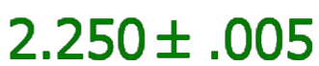 is known as what type of tolerance?
 | A. | Stacked limit | C. | Bilateral
 | B. | Unilateral | D. | General
34. | Many times a small assembly is created and then brought into a larger assembly. The small assembly is commonly referred to as a(n) __________.
 | A. | Micro assembly | C. | Subassembly
 | B. | Component cluster | D. | Parts pod
35. | If all of the dimensions on a part have the same precision as the dimensions below, which part would cost the most to machine?
 | A. | 3.98 in. | C. | 3.9 in.
 | B. | 4.102 in. | D. | 4.00 in.
36. | How many degrees of freedom (DOF) remain on an ungrounded part after a single insert constraint has been applied?
 | A. | 0 | C. | 2
 | B. | 1 | D. | 3

37. | What part below would require an auxiliary view for manufacture?
 | A. | 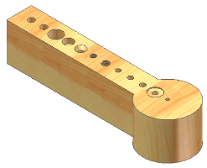 | C. | 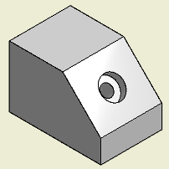
 | B. | 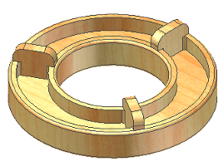 | D. | 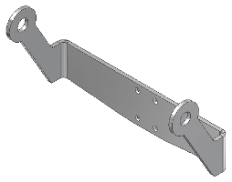
38. | 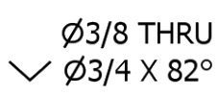 is a callout for what type of hole?
 | A. | Blind hole | C. | Spotface
 | B. | Counterbore | D. | Countersink

39. | What type of hole should be modeled if the hole is to have a bolt tightened into it?
 | A. | Blind hole | C. | Tapped hole
 | B. | Countersink hole | D. | Clearance
40. | Close, loose, and normal are options that can be selected for creating what type of hole?
 | A. | Angled | C. | Tapped
 | B. | Threaded | D. | Clearance

41. | What part below would require a section view for manufacture?
 | A. | 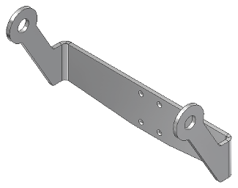 | C. | 
 | B. | 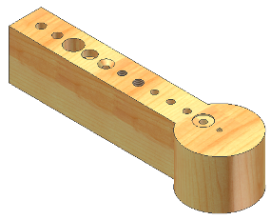 | D. | 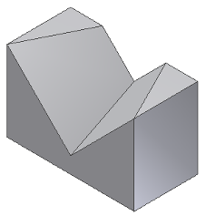

42. | What type of document includes the following section headings?  - Client  - Problem statement  - Design statement  - Constraints  - Deliverables
 | A. | Specification sheet | C. | Design brief
 | B. | Title block | D. | Parts list

43.
  What tool used during the design process is pictured to the right? | 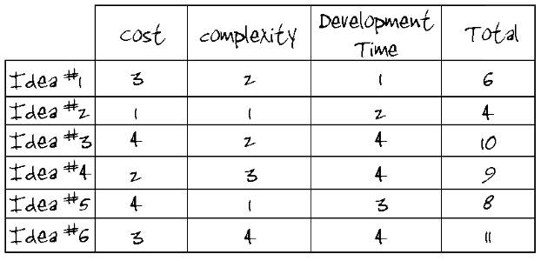
 | A. | Parts list | C. | Decision matrix
 | B. | Bill of materials | D. | Specification sheet
44.
  What type of dimensioning technique is pictured on the view to the right? | 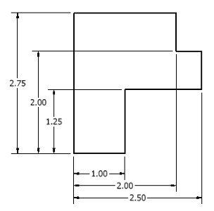
 | A. | Chain/Series | C. | Aligned
 | B. | Reference/Baseline/Datum | D. | Alternate units
45. | d2*.5 is considered what type of constraint?
 | A. | Assembly | C. | Geometric
 | B. | Numeric | D. | Design
46.
  What type of dimensioning technique is pictured on the view to the right? | 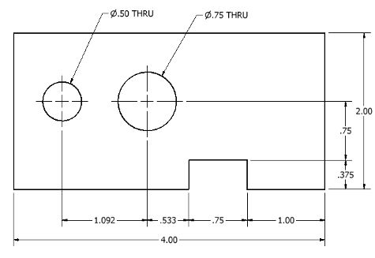
 | A. | Chain/Series | C. | Reference
 | B. | Baseline | D. | Datum
47.
  What is the volume of the part to the right? | 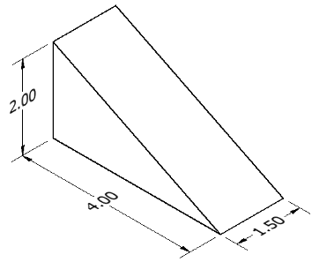
 | A. | 8 in.³ | C. | 6 in.³
 | B. | 12 in.³ | D. | 16 in.³
48. | The Coordinate System that uses a distance and an angle to plot points is called
 | A. | Polar | C. | Absolute
 | B. | UCS | D. | Relative
49.
  If the two alignment pins on this mold need to be pressed into the holes shown because the pins are .003 larger than the drilled holes, this would be a(n) ___________________ fit. | 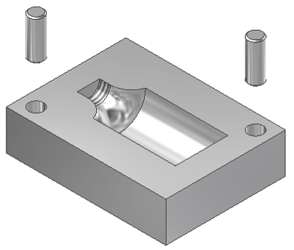
 | A. | Alignment | C. | Clearance
 | B. | Normal | D. | Interference
50.
  After a single mate assembly constraint has been applied between Part B and the grounded part, how many degrees of freedom (DOF) remain on Part B? | 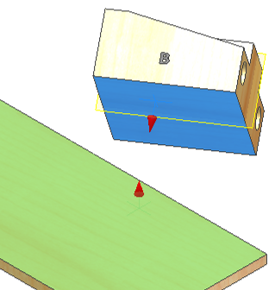
 | A. | 1 | C. | 3
 | B. | 2 | D. | 4

1. Place the letter of the line type that best matches each line type indicated in the illustration below (1.1, 1.2, 1.3, 1.4, and 1.5). Answers from the answer bank may be used only once.
[5 POINTS – 1 point each]

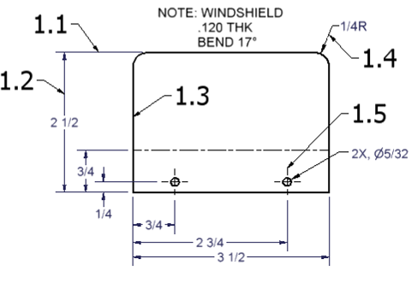

Answer Bank

A. Extension line | B. Object line
C. Section line | D. Leader line
E. Hidden line | F. Dimension line
G. Center line | H. Construction line

2. Read the narrative below. Select the letter from the answer bank that best indicates which step of the design process is being described in items 2.1 through 2.5.
[5 POINTS – 1 point each]

Narrative: The Great Eight Engineering firm has been contracted to create a new Computerized Water Fountain system for Spring Isle Mall. The engineering team, led by Ms. Jessica Evans, has 10 months to design, test, and present an initial prototype to mall management.

2.1 Jessica schedules a second meeting between her engineering team and the mall management team so that her team can draft a design brief.

2.2 A few members of the engineering team travel to several sites across the country that currently have computerized water fountains. The engineering team records detailed notes and takes many digital pictures.

2.3 Working from the set of plans developed by the CAD department, skilled fabricators construct a ¼ scale replica of the engineering team’s initial design idea.

2.4 After testing and evaluating the product, several items are found that need improvement or are out of specification. CAD drawings are modified.

2.5 Jessica’s engineering team uses several decision matrices to arrive at a final design plan.

Answer Bank
- Define a problem
- Brainstorm
- Research and generate ideas
- Identify criteria and specify constraints
- Explore possibilities
- Select an approach
- Develop a design proposal
- Make a model or prototype
- Test and evaluate the design using specifications
- Refine the design
- Create or make solution
- Communicate processes and results

3. Use the drawing of the hood to answer the following questions. Select the correct answer from the answer bank below. Each selection may only be used once.
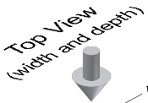
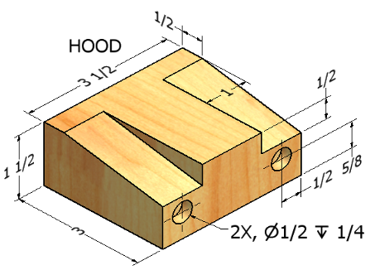
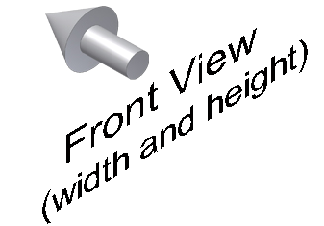
[5 POINTS – 1 point each]
Note: Notice the two surface indicators.

3.1 What is the overall width of the hood?

3.2 What is the width of the inclined surface?

3.3 What is the height dimension to the
center of the holes?

3.4 What is the overall height of the hood?

3.5 To what depth should the holes be drilled?

Answer Bank

A. ¼ in. B. 1 in. C. 1 ½ in. D. 3 ½ in. E. 5/8 in.

4. Parts of a Drawing Sheet – Match the letter from the answer bank below for items 4.1- 4.5. Each selection can only be used once.
[5 POINTS – 1 point each]
Answer Bank

A. Title block B. Detail drawings C. Parts list D. Balloon
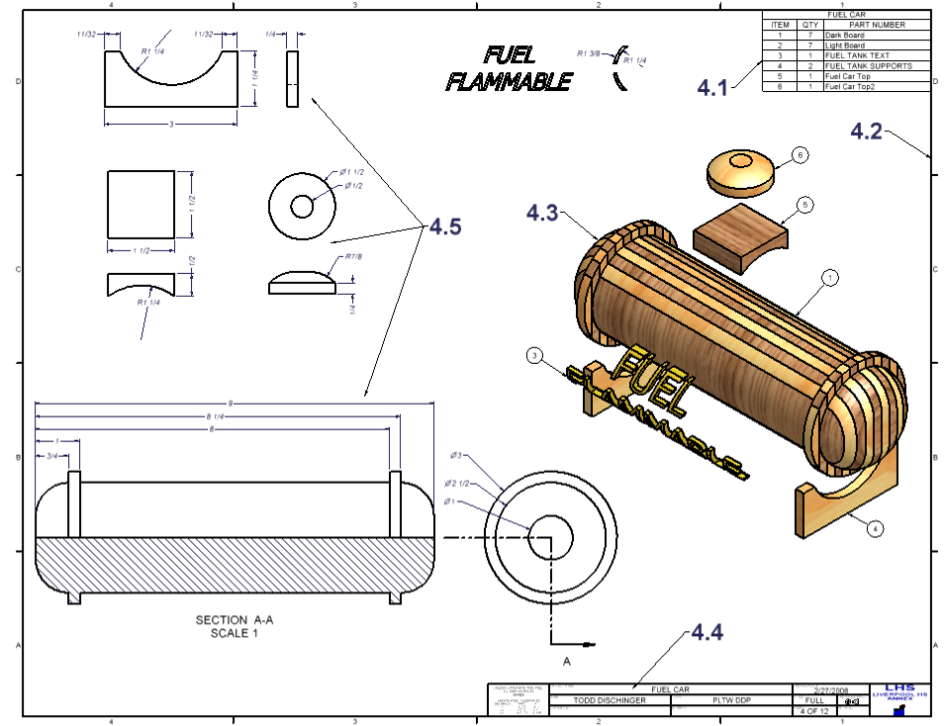
E. Scale F. Exploded view G. Border H. Assembly
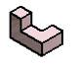
5. Basic Steps to 3D Model a Part – Arrange the steps (workflow) below in the proper order to model the part pictured to the right. [5 POINTS – 1 point each]

A. Apply a new sketch to the back surface and sketch a square
B. Constrain and dimension
C. Dimension and then extrude - Join
D. Sketch an “L” shaped profile
E. Finish the sketch and extrude

Unit 2 – Part B
6. Match the letter of the correct physical property from the answer bank to the corresponding scenario. [5 POINTS – 1 point each]

6.1 A student has just modeled an attractive and practical hydration system for ultra-distance runners but does not know how many ounces the container holds.

6.2 TCD Designs wants to order enough material to paint 500 puzzle parts.

6.3 Alliance Glass Products, Inc. has just completed a prototype of a flower vase. During initial testing, the product tipped over several times after long-stemmed flowers were placed in the vase.

6.4 A robotics team wants to calculate the cost to ship their robot to various competitions. FedEx charges $68.59/100 lb.

6.5 A student has designed a part for an assembly. The student has three materials to choose from to make the prototype – 6061 aluminum, polycarbonate, or delrin. The overall weight of the assembly is a concern.

Answer Bank

A. Mass B. Center of gravity C. Volume D. Surface area E. Density

7. Select the image below that matches the assembly constraint that is to be applied. [5 POINTS – 1 point each]

7.1 Flush with offset
7.2 Mate – face to face
7.3 Angle – face to face, 330 degrees
7.4 Mate – face to edge
7.5 Insert

A. 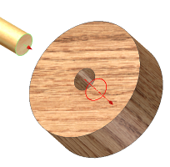 B. 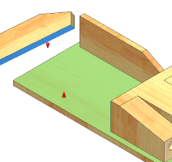 C. 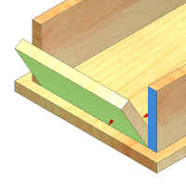

D. 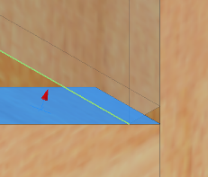 E. 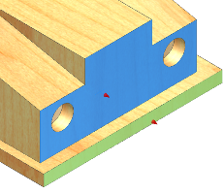

8. Place the letter of the line type that best matches each line type indicated in the illustration below (8.1, 8.2, 8.3, 8.4, and 8.5). Answers from the answer bank may be used only once.
[5 POINTS – 1 point each]
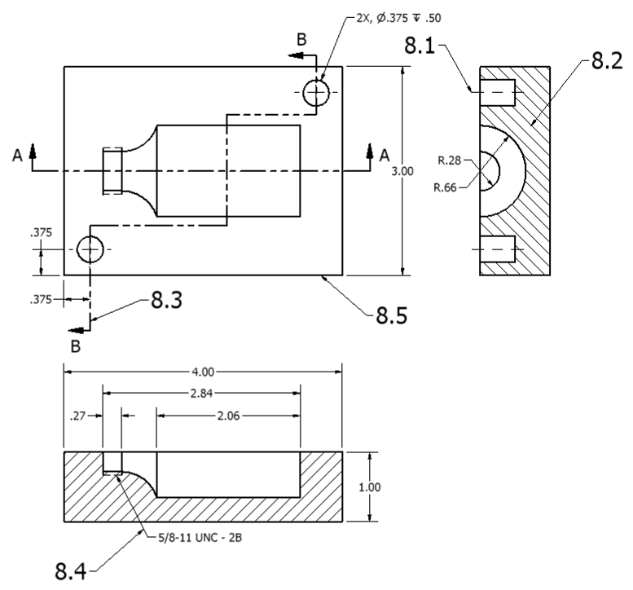

Answer Bank

A. Extension line E. Hidden line
B. Object line F. Dimension line
C. Section line G. Center line
D. Leader line H. Cutting plane line

9. Match the letter of the sketch tool from the answer bank to the corresponding image below.
[5 POINTS – 1 point each]

9.1 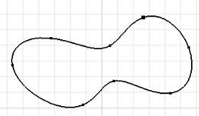 9.2 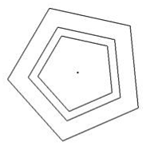 9.3 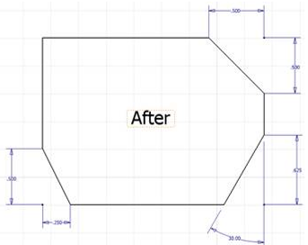

9.4 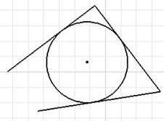 9.5 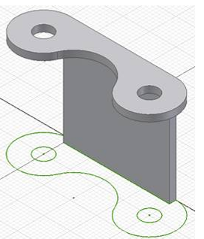

Answer Bank

A. Tangent circle B. Spline C. Chamfer
D. Offset E. Project geometry F. Fillet
G. Center point circle H. 3 point arc I. 3 point rectangle

10. Match the feature (10.1- 10.5) to the BEST selection listed in the answer bank below. Each selection may only be used once.
[5 POINTS – 1 point each]
10.1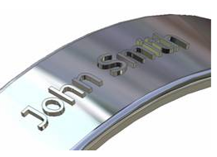 10.2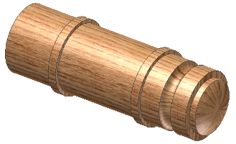 10.3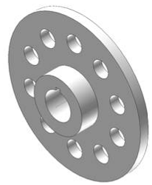

10.4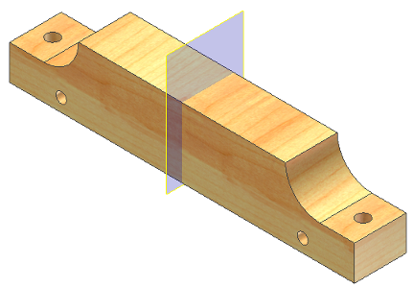 10.5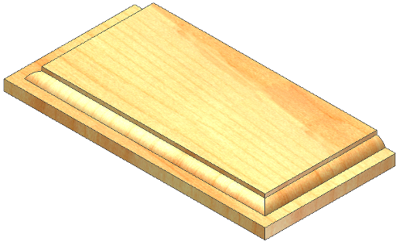

Answer Bank

A. Loft B. Fillet C. Sweep D. Revolve

E. Derived component F. Mirror G. Decal H. Chamfer

I. Circular pattern J. Rectangular pattern K. Decal

L. Rib M. Emboss N. Shell O. Coil

