Project 8.1c Model A Miniature Train

Introduction
Have you ever ridden on a train or owned a train set? The parts that make up the engine car on a train can vary depending on the make and model; however, all train engine cars have parts that are similar.

Interpreting dimensioned drawings is an important engineering skill. Using drawings to create a computer model of a part is also important. You learned earlier in this course that a sketch is the documentation foundation for related technical work. Communicating this information effectively allows a group of people to function as a design team.

In this project you will further develop your modeling skills and your ability to use a computer as an efficient communication tool. The skills that you learned earlier in this course will be systematically applied to model the eight remaining parts needed for the Miniature Train Assembly. The parts with the dimensions are listed below.

Equipment
Computer with 3D CAD solid modeling program
Engineering notebook

Procedure
- Model and assemble the parts shown using the drawings provided.

Train Parts List
Item | Quantity | Name | Description | Material
1 | 1 | Train Body |  | ABS Plastic
2 | 1 | Stack |  | ABS Plastic
3 | 1 | Hitch Magnet |  | ABS Plastic
4 | 1 | Hitch Peg |  | ABS Plastic
5 | 4 | Wheel |  | ABS Plastic
6 | 4 | Axle Peg |  | ABS Plastic
7 | 2 | Linkage Arm |  | ABS Plastic
8 | 4 | Linkage Peg |  | ABS Plastic
9 | 1 | Cow Catcher |  | ABS Plastic

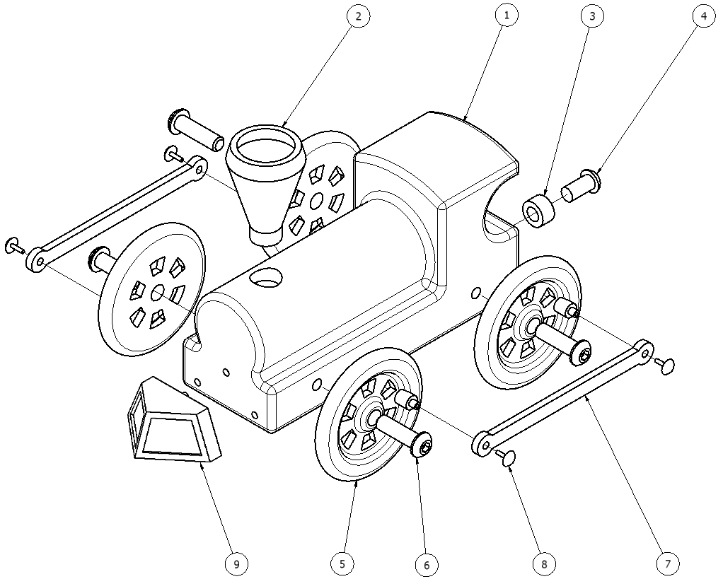
Train Tolerances
All parts have the following tolerances:
X.X = +/- .020
X.XX = +/- .010
X.XXX = +/- .005

Part #1: Train Body
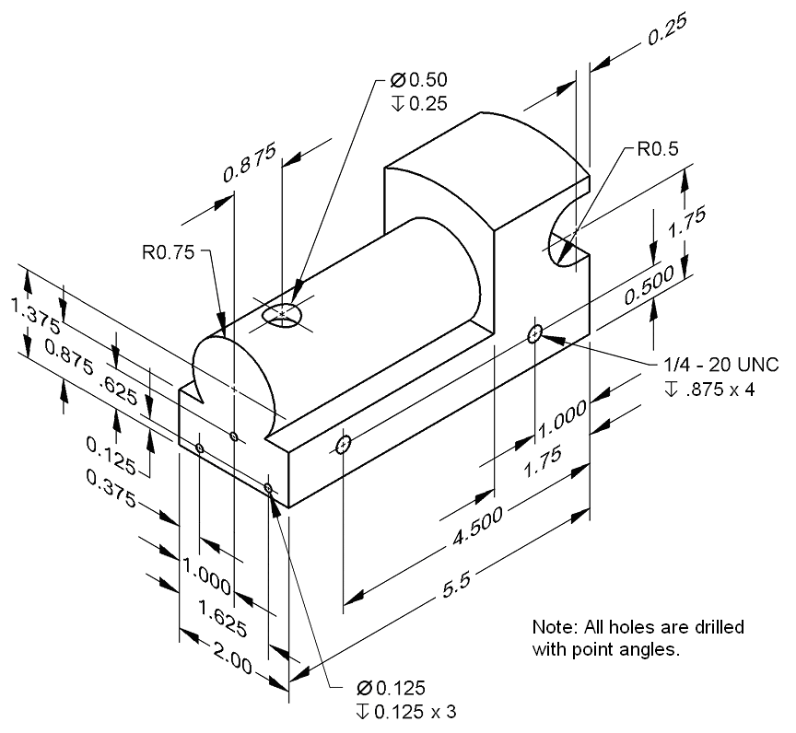

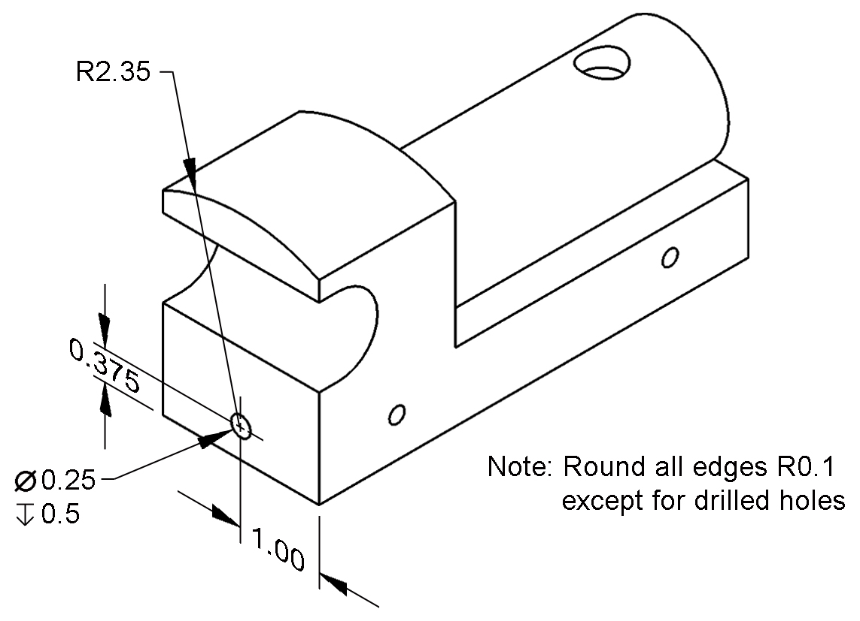

Part #2: Stack
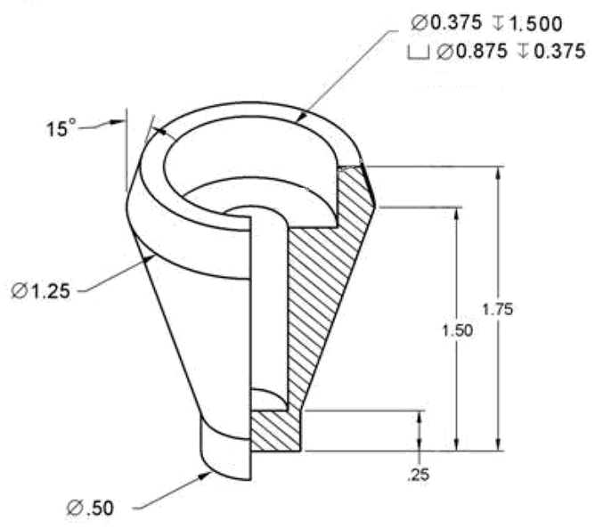
Note: Optional chamfer bottom edge .01 x 45 deg

Part #3: Hitch Magnet
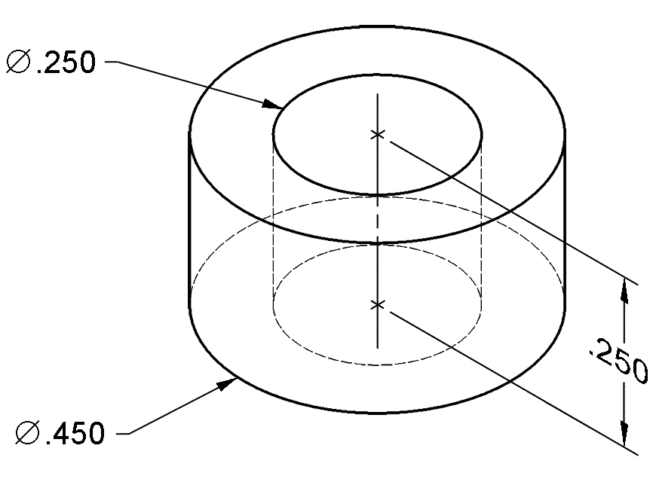

Part #4: Hitch Peg
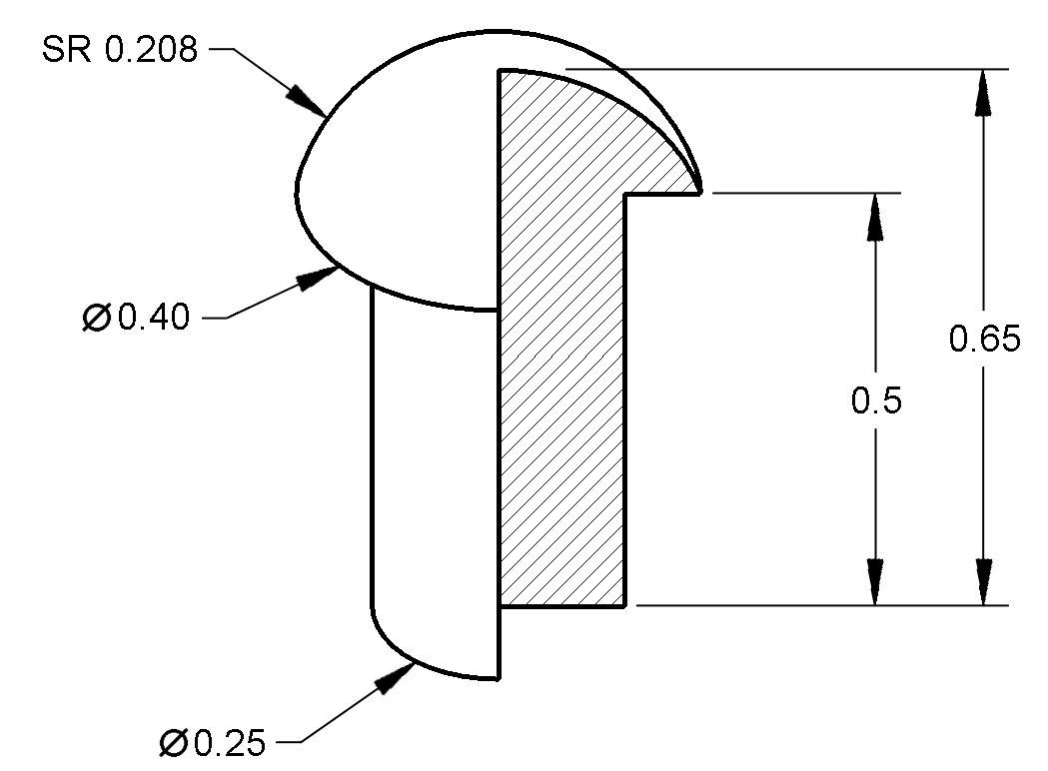
Note: Optional chamfer bottom edge .01 x 45 deg

Part #5: Wheel
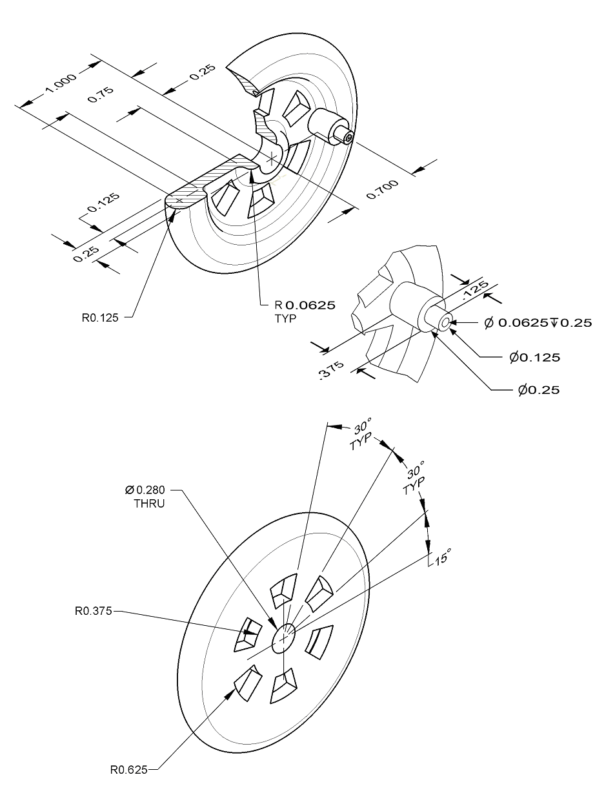

Part #6: Axle Peg
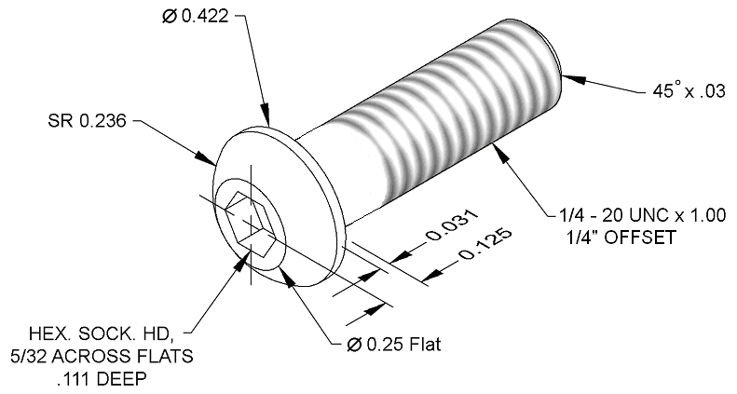

Part #7: Linkage Arm
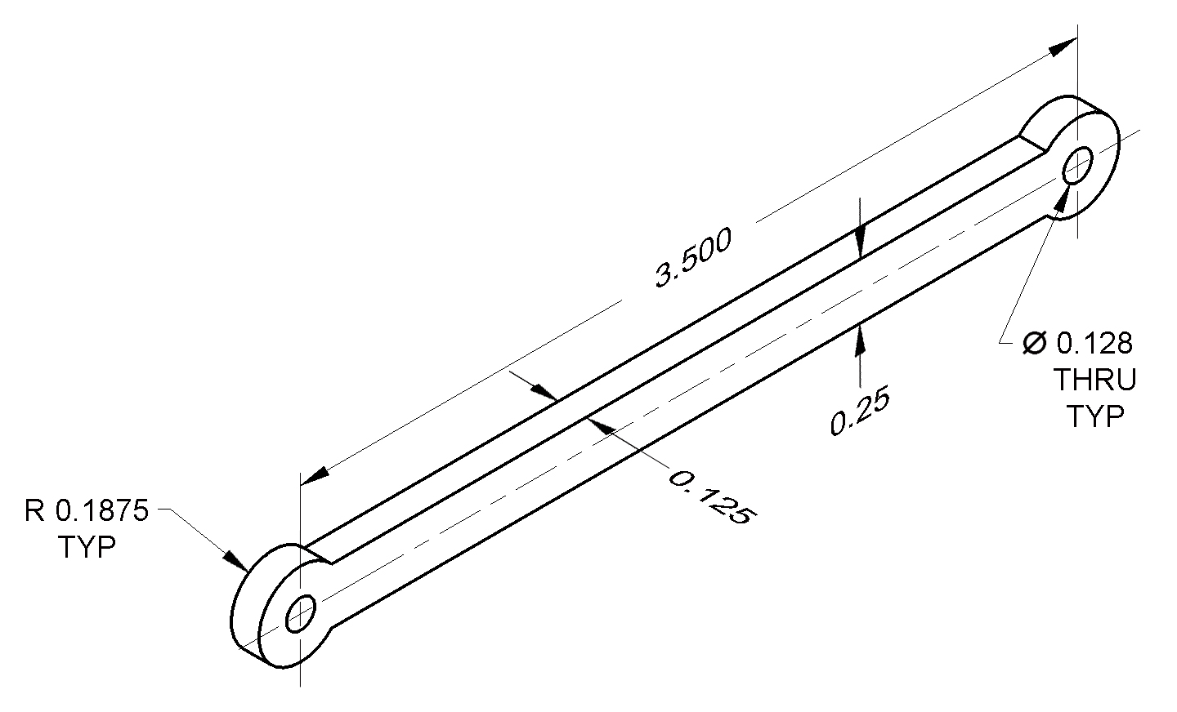

Part #8: Linkage Peg
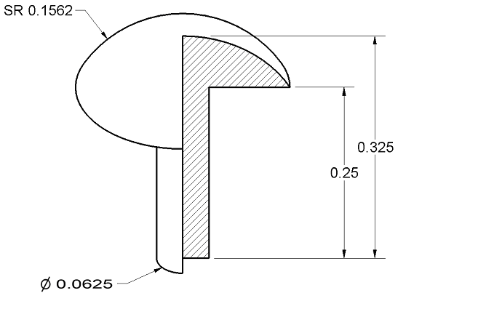
Note: Optional chamfer bottom edge .01 x 45 deg

Part #9: Cow Catcher
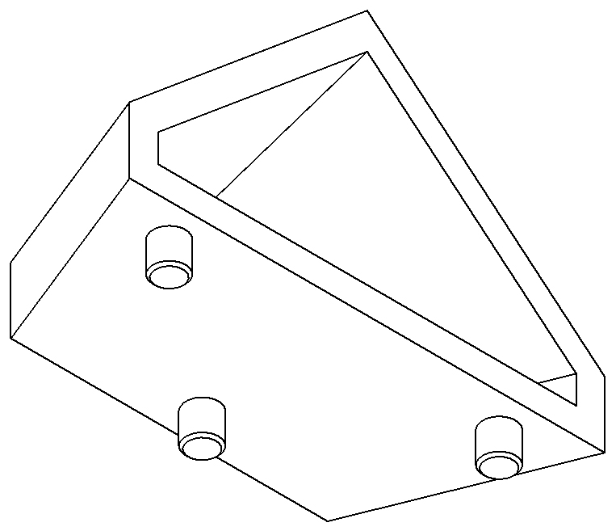

Assembled Train
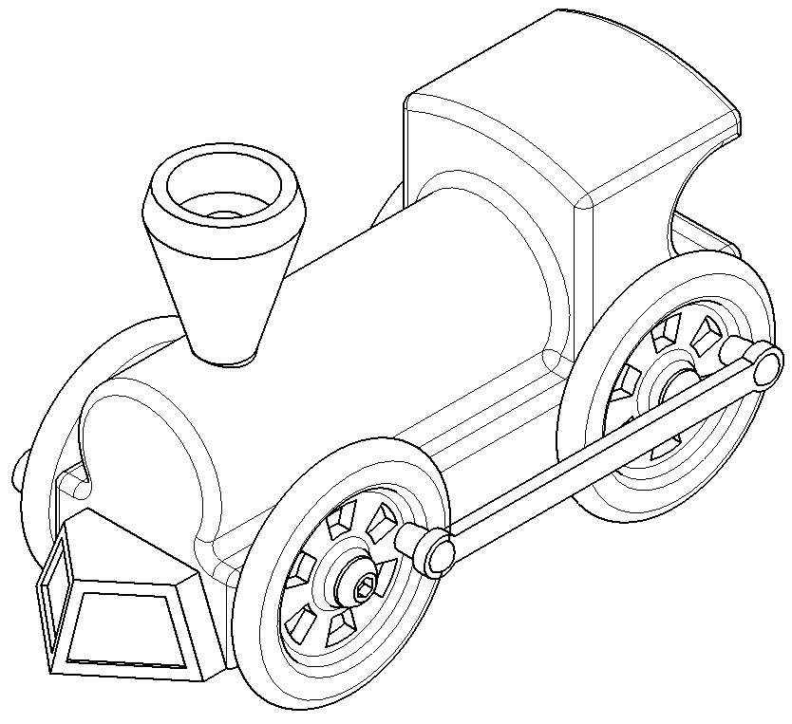

Straight Track
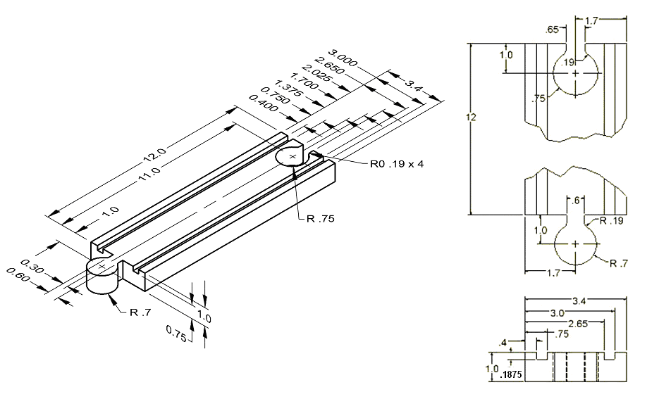

Conclusion
- Why are drawings composed of different line conventions?

- What is the purpose of a sectional view?

- What is the purpose of an auxiliary view?

- Why are symbols used instead of words to identify hole types?

- What advantage is there to using algebraic equations instead of numerical values when defining the dimensions of a CAD model?

- What three types of constraints can be applied to CAD sketches or models?

- What advantages do CAD drawings have over paper sketches?

