Activity 5.5 CAD Model Features

Introduction
Two dimension sketches are nice, but parts have three-dimensional (3D) qualities that sketches can only imitate and communicate in an abstract manner. A sketch in a 3D Computer Aided Design (CAD) solid modeling program serves as the foundation for a three-dimensional feature. Some three-dimensional features do not require sketches, but they do require an existing three-dimensional object. Now that you have experience with the various two-dimensional sketch tools that a CAD modeling system has to offer, it is time to learn about some of the more common 3-D options that designers use to create computer models of design solutions.

As is the case with sketched geometry, 3D CAD features can be made to perfect dimensional accuracy. The ability to realize CAD models through sequentially adding and subtracting three-dimensional features is a critical skill that designers in multiple engineering disciplines use to make mental images into money-making products.

Equipment
- Computer with 3D CAD modeling software
- CAD files:
      - Bushing
      - Circular Pattern
      - Drilled Holes
      - Extrude-Taper
      - Fillet Chamfers
      - Intersect
      - Left Half
      - Loft
      - Paper Clip
      - Rectangular Pattern
      - Rib Support

Procedure
In order to effectively use a CAD program as a design tool, a designer must know what model features are available and how they work. This activity will help you to understand and utilize the feature tools that are common to most CAD programs.

Tapered Extrusions
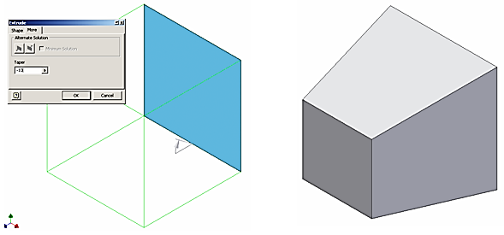

- Extruded objects can be given a positive or negative taper angle. A common example of a tapered extrusion is the design of an ice cube. The sides of the ice cube are tapered with a draft angle to allow the cube to be easily removed from the ice cube tray. Open the file called Extrude-Taper, and extrude the square a distance of 1 inch with a taper angle of -10°. Save the file as a different name.

CAD file name and location:

- Open the part file SquareFigureYourInitials.ipt that you created in Activity 5.2. Use a tapered extrusion to approximate the body of the figure. Save the file to your project folder.
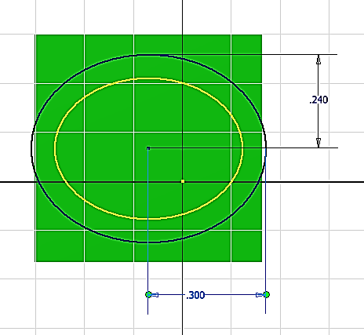 | 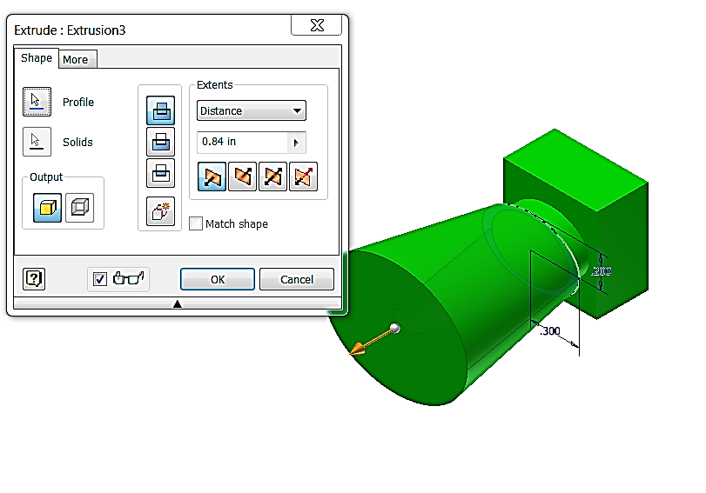
Intersect Extrusions
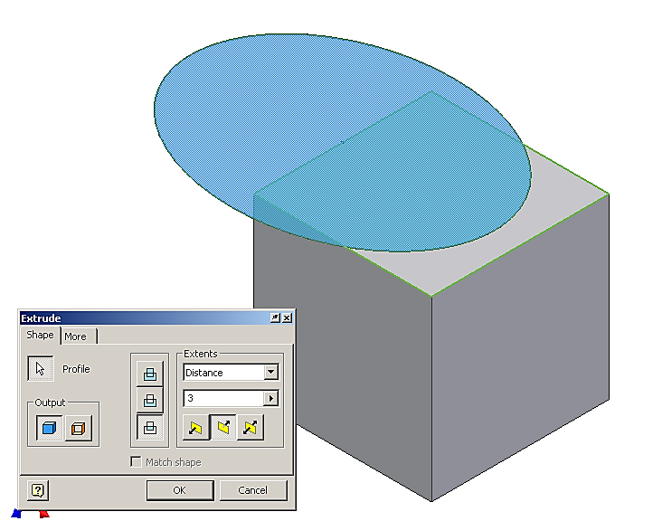 | 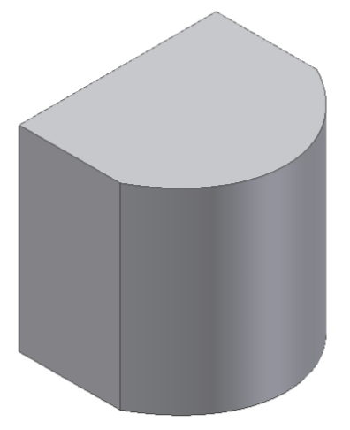

- The intersect extrusion function will perform a Boolean addition and subtraction in one operation. Any part of the sketch profile that overlaps existing geometry will remain. The portion of the sketched profile and the existing geometry that do not overlap will be removed. Open the file called Intersect and perform an intersect extrusion on the sketch all the way through the existing object to observe what takes place. Note that the dialog box may appear different in other versions of Inventor. Save the file as a different name.
CAD file name and location:

- Edit the SquareFigureYourInitials.ipt part to approximate the curve of the shoulders using the Intersect extrusion.
  - Place a work axis through the center point along the long axis of the ellipse of the body.
  - Choose a face of the square base that is parallel to the long axis of the ellipse that was used to create the body. Place a new sketch on this face of the square base.
Right click on the sketch and Slice Graphics so that you can see sketch lines that intersect with the existing geometry (see image below).

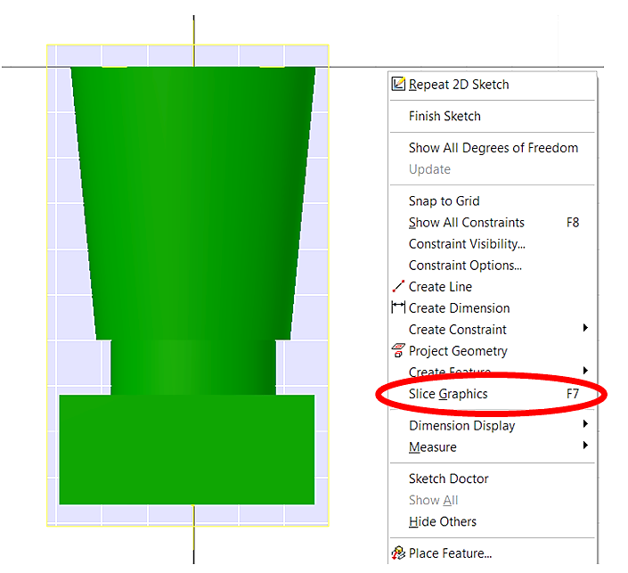
Helpful Hint: Slice Graphics will cut the part at the current sketch plane and remove the solid material in the foreground (similar to a section view). This will allow you to see the geometry at the sketch plane and can provide better visibility of the sketch plane by removing obstructing material.
  - Project Geometry of the work axis onto the sketch.
Helpful Hint: Project Geometry is a tool that will project the geometry of previously created features of a part onto the sketch plane so that you may use the geometry in the construction of the sketch. The Project Geometry tool is accessible in the Sketch Ribbon in the Draw panel.
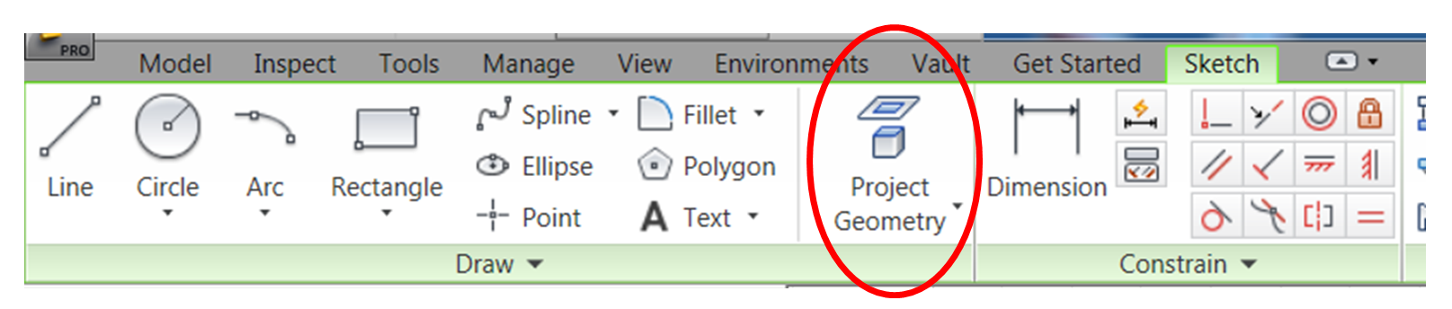
  - Sketch an arc and center it on the figure that will approximate the curve of the shoulders on the figure. Do not worry about exact dimensions. Provide a reasonable approximation of the figure shoulder contour (see image below).
  - Complete the sketch with lines that will encompass all of the existing geometry of the figure below the arc. Since you will be using the Intersect extrusion tool, you want to include all of the lower geometry within this sketch.
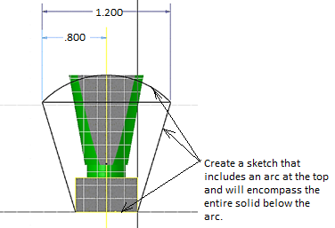
  - Perform a Midplane (or Symmetric) Intersect extrusion. Note that the dialog box may appear different in other versions of Inventor.
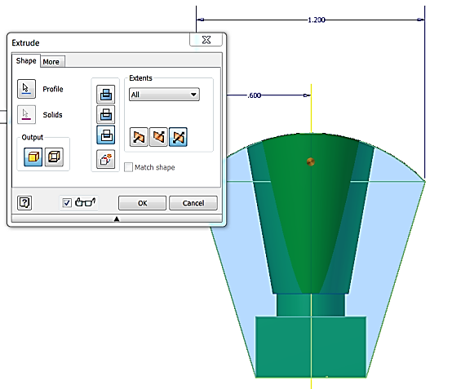 | 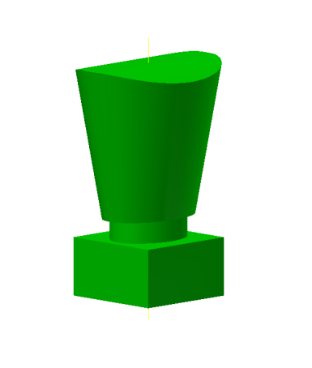
  - Save the file to your Automoblox project folder.
Hole
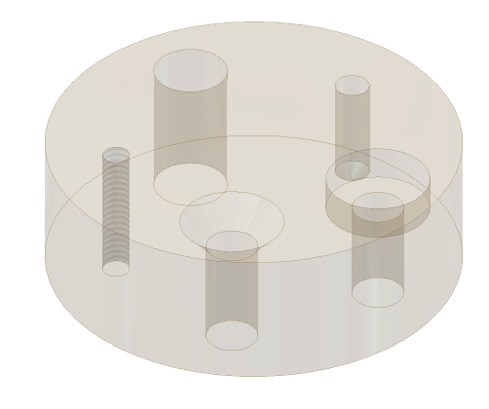

- The Hole function requires a hole center for each instance. Open the file called Drilled Holes. The existing feature is a blind hole, and has been created for you. The following page shows the different function windows that are associated with a counterbore, countersink, threaded hole, and clearance hole. The center of each hole is a point placed in a sketch. All points in a sketch will be auto-selected by the computer when the Hole command is initiated. You will have to hold down the shift key to deselect the hole centers that you do not want – be sure the Centers button is depressed. Work your way around the block in a clockwise direction initiating the Hole function, selecting the appropriate hole center, and identifying the type of hole feature that is needed. The counterbore will have a major diameter of .75 inch that is recessed .25 inch. From there, the through hole will have a diameter of .375 inch. The countersink has a major diameter of .75 inch, with a taper of 83. The threaded through hole has a nominal diameter of .25 inch, and a 1/4-20 thread applied to its interior wall. The clearance hole goes through the disc, and has a diameter of .531 inch. Note: a shared sketch will not disappear after the first feature is created. Save the file as a different name.
CAD file name and location:

Through (THRU) Hole
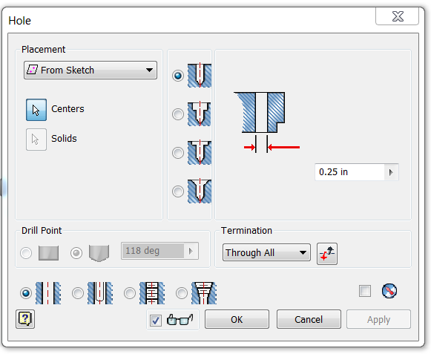 | 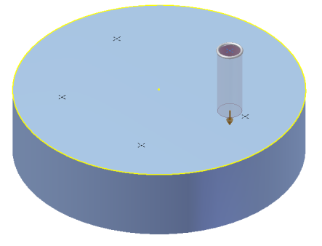
Counterbore
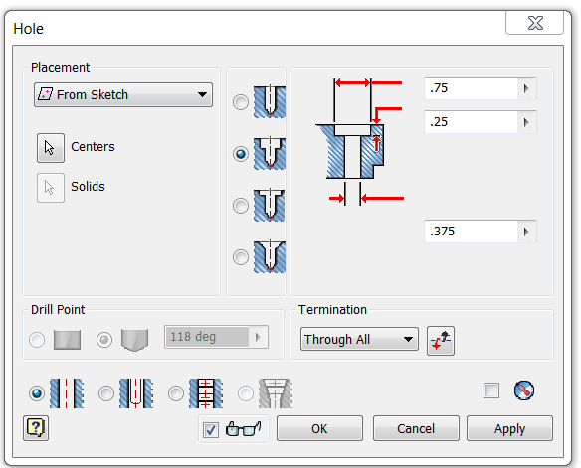 | 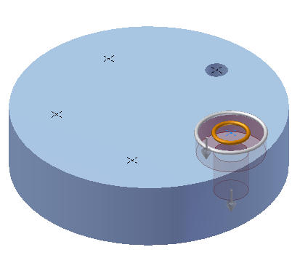
Countersink
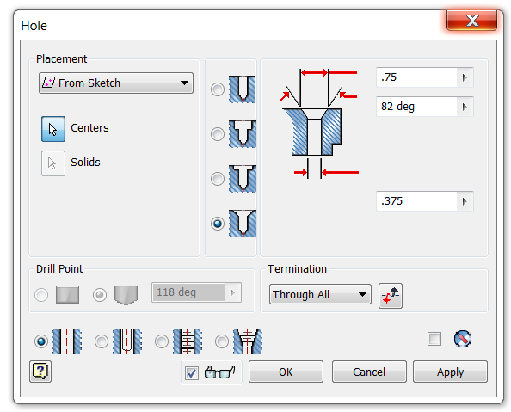 | 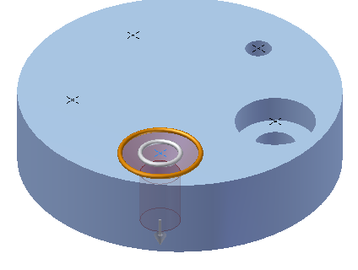
Threaded Hole
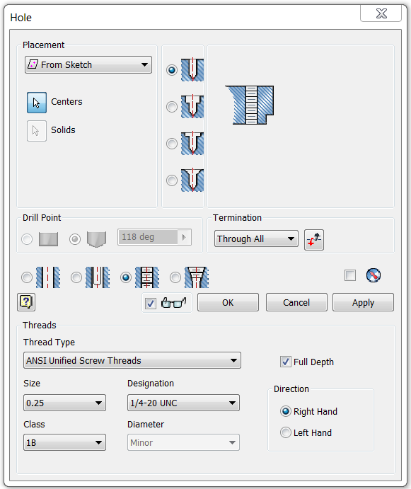 | 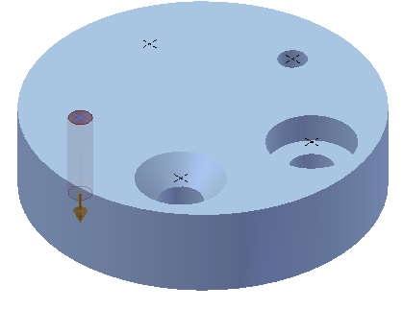
Clearance Hole
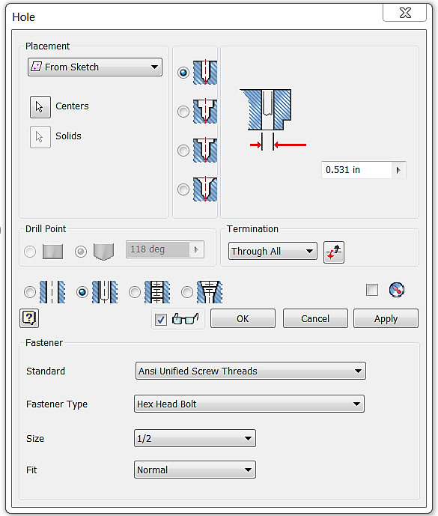 | 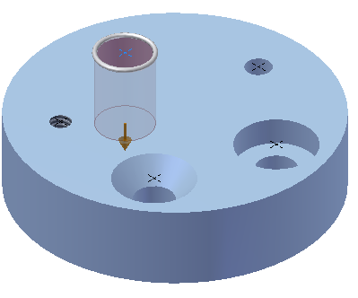

Revolve
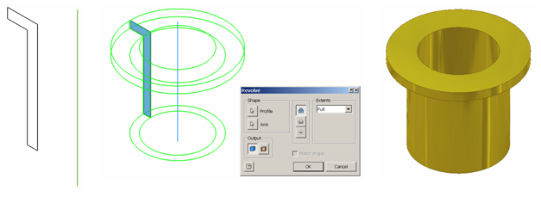
- Revolve is a function that allows the user to extrude a closed profile around a fixed axis up to 360°. The axis can be part of the profile, an existing edge on a part, or one of the axes of the Cartesian coordinate grid. Grid axes may be selected from the Origin folder located in the Browser bar. Open the file called Bushing. Use the revolve function to revolve the sketch around the existing axis a full 360°. Save the file as a different name.
CAD file name and location:

- Use the Revolve function to create the Rubber Handle Sleeve part for the Button Maker as shown in the dimensioned drawing below. Remember to create only half of the section and revolve it a full 360 degrees. You can include a line in the sketch to act as the axis of revolution. Save the file as RubberHandleSleeveYourInitials.ipt in your Button Maker project folder.
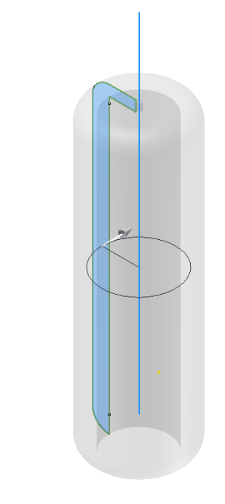 | 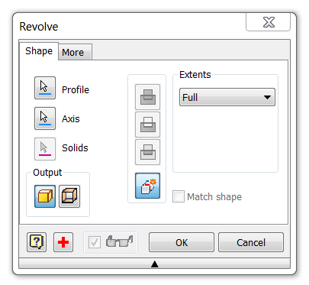

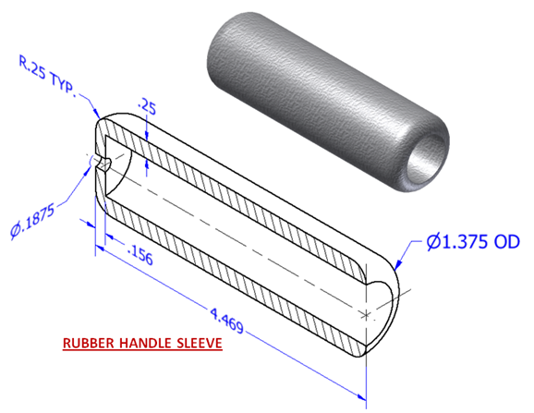
- Use the Revolve tool to create a 3D solid CAD model for the Upper Die Center for the Button Maker using actual measurements or the dimensioned pictorial. The hole identified with the thread note is a single hole. Save the part file as UpperDieCenterYourInitials.ipt to your personal Button Maker project folder.
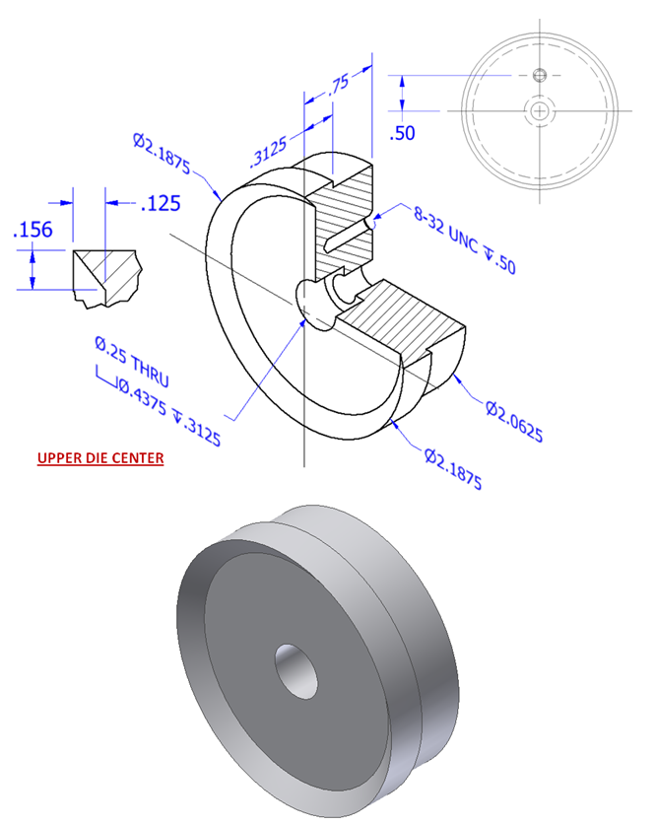

- Create a 3D solid model of an axle for the Automoblox vehicle using the Revolve tool. Use your measurements or the dimensioned pictorial drawing. Then model one cut in the end of the axle and use the Circular Pattern tool or Mirror tool to create the second cut. Save the file as AxleYourInitials.ipt to your Automoblox project folder.
- Open SquareFIgureYourInitials.ipt. Create a workplane through the center of the figure and place a sketch on the work plane. Create a sketch to approximate the shape of the head of the figure – do not try to model the shape exactly. Your sketch should include a line on the work axis through the ellipse that you previously created. Then revolve the shape around the work axis of the ellipse that you previously created. Save the file to your Automoblox project folder.

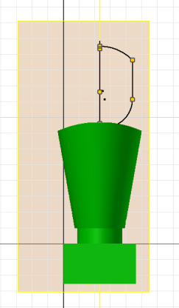 | 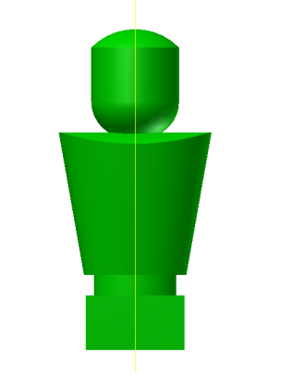

Loft
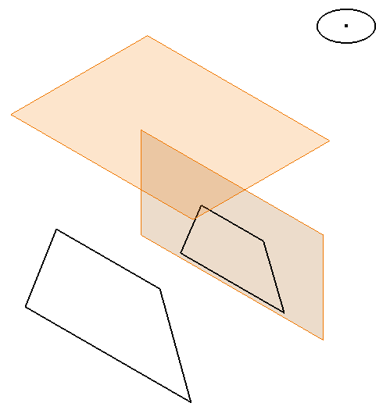 | 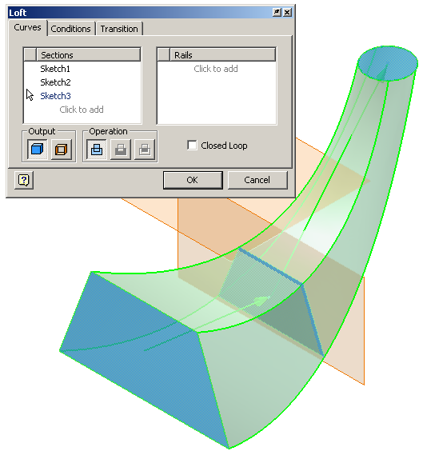

- The loft function allows the user to create a solid or surface by blending two or more shapes that are located on different planes. Open the file called Loft. Use the Loft function to blend the three profiles into one solid object. Save the file as a different name.
CAD file name and location:

- Revisit the Triangular Figure part file that you created in Activity 5.2. Edit the part to more closely represent the elliptical portion that represents the legs on the figure using the Loft tool.
  - Delete the elliptical extrusion in the part and replace it with a loft. Be sure to retain the original sketch containing the ellipse. You will need to create a workplane on which to create a new sketch of a larger ellipse. Use your measurements of the part or the measurements shown below.
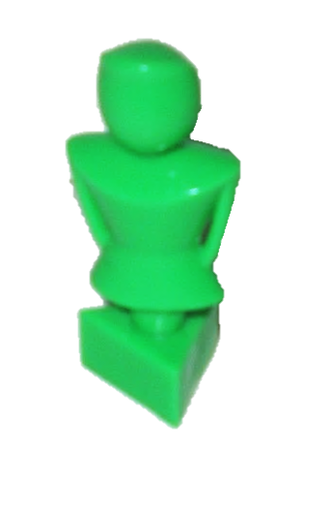 | 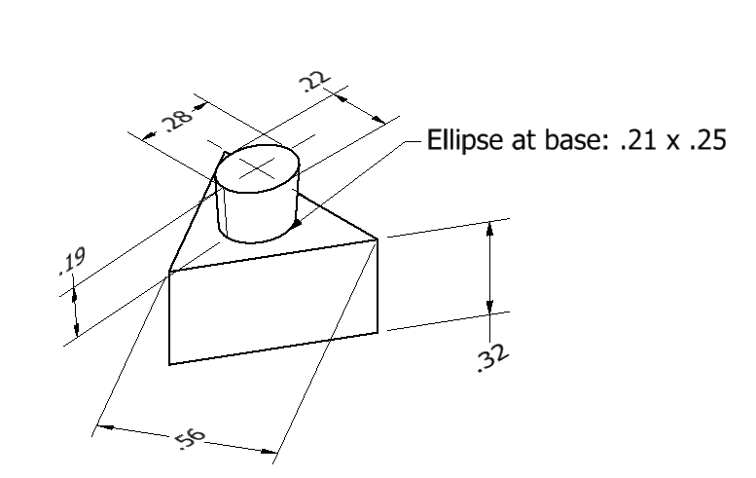
  - Next, use the Loft feature to create the remainder of the body of the triangular figure. Compare two different methods of creation. First, try using a Loft involving three sketches. Then try using two separate lofts. Choose the method that most closely resembles the actual figure. Use your measurements or the measurements shown below.
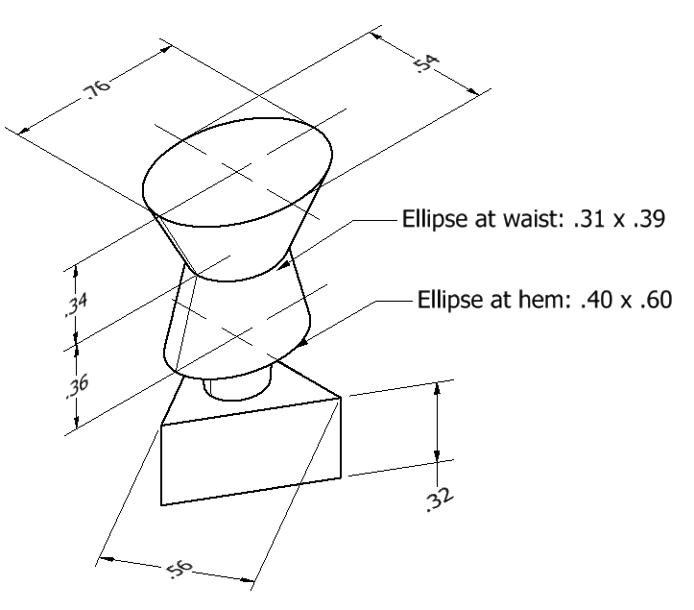 | 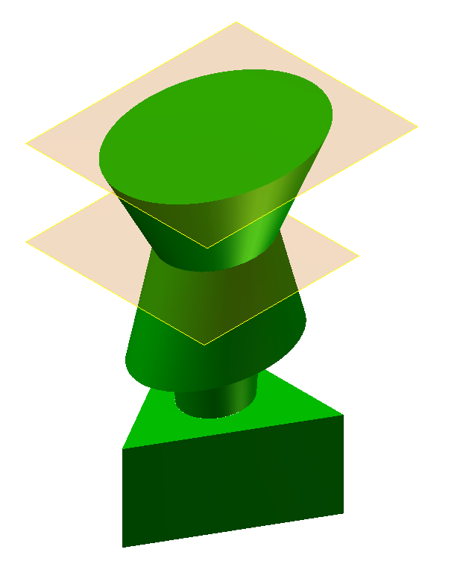
Circular Pattern

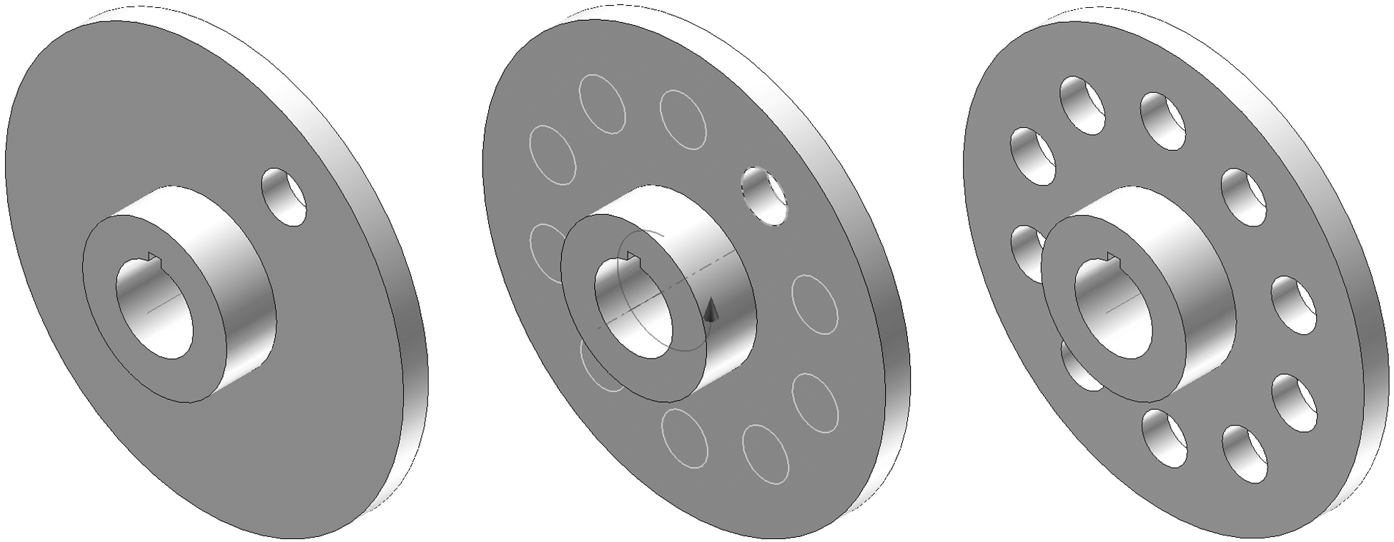

- The pattern function allows the user to make multiple copies of an existing feature (as opposed to a sketch line as discovered in Activity 5.2 Making Sketches in CAD) in one of three ways. A circular pattern is often used to array a hole around a center axis. An edge on an existing feature can also serve as the center axis. Open the file called Circular Pattern, and use the circular pattern function to copy the existing hole on the flange plate a total of 10 times (the first hole must be represented in the count) around the existing work axis. Save the file as a different name.

CAD file name and location:

- Create a 3D solid model of the Automoblox tire. Use your measurements or the dimensioned pictorials. The dimensions shown in the images below are for reference only. Save the file as TireYourInitials.ipt
- Sketch concentric circles and use a Midplane (or Symmetric) extrusion to create the rubber ring.
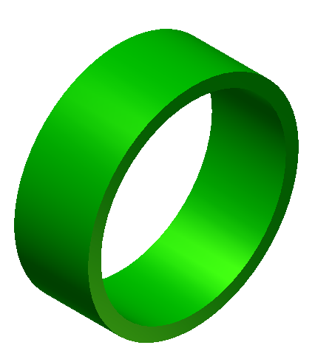
- Share the sketch by right clicking on the sketch in the Project Browser (under Extrusion1 parent) and choosing Share Sketch. An unconsumed copy of the Sketch will appear in the browser.
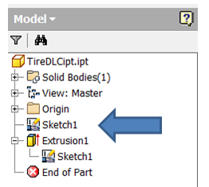
- Edit the sketch to create the geometry for one internal rib using a concentric circle, lines, and the Trim tool.

- Use another Midplane (or Symmetric) extrusion to create a single rib.
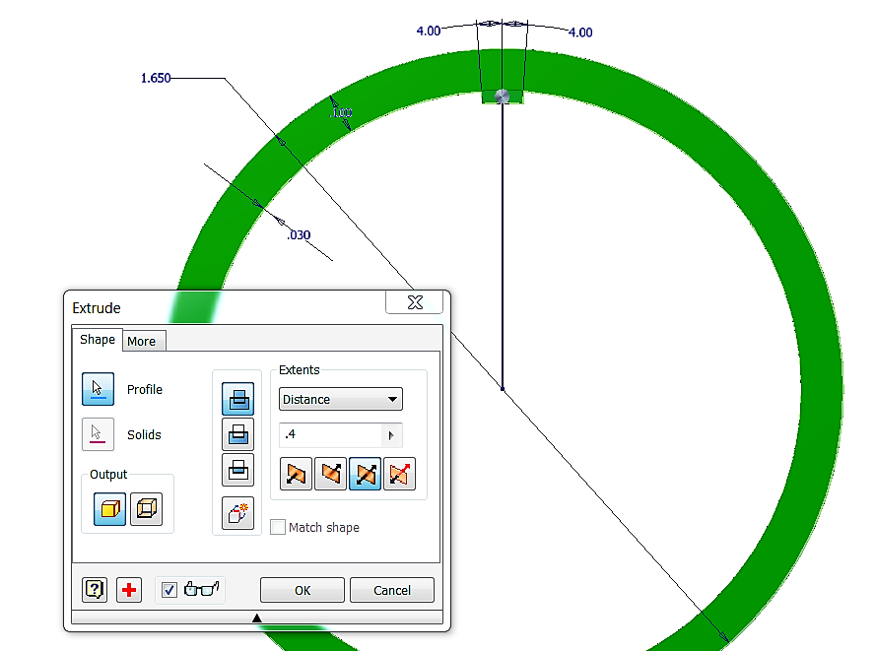
- Create a Work Axis using the Through Center of Circular or Elliptical Edge. You must select the appropriate axis tool, and then select one of the circular edges on your model. This work axis will act as the center of the circular pattern.
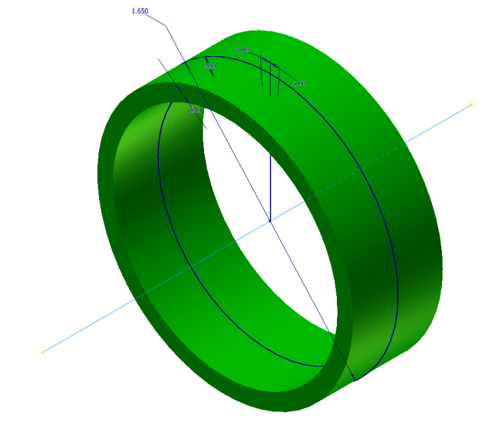
- Use the circular pattern tool to create the remaining ribs.
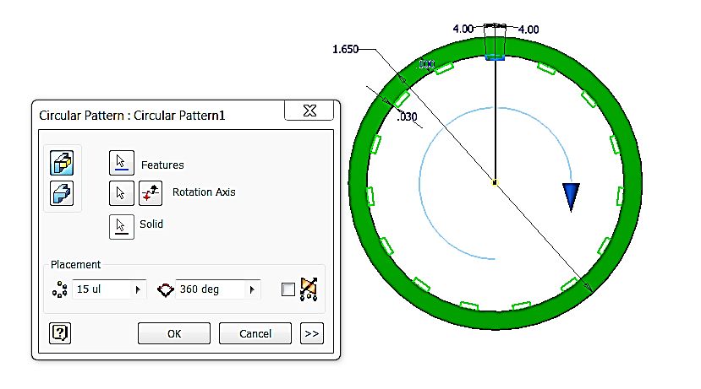

- Use the Shared Sketch again to create the thin extrusion that runs around the inside center of the tire.
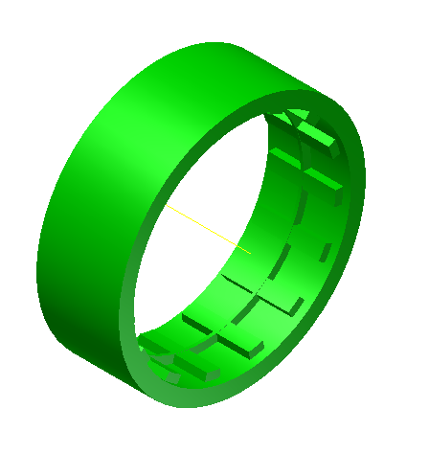

- Model the Upper Die Pressure Ring for the Button Maker using the dimensioned drawings below. Use the Revolve and Circular Pattern tools. Save the file as UpperPresRingYourInitials.ipt in your Button Maker project folder.
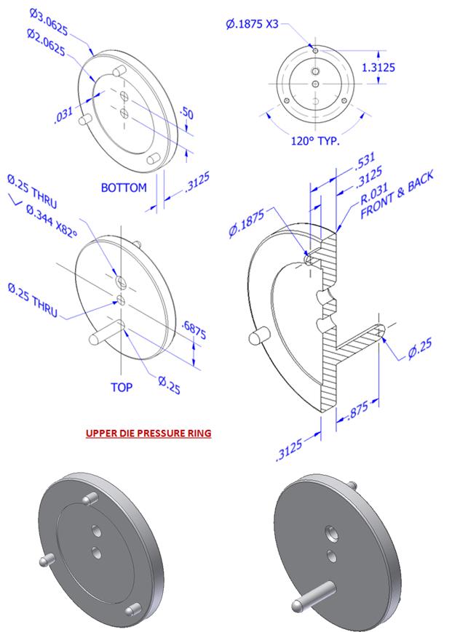

Rectangular Pattern

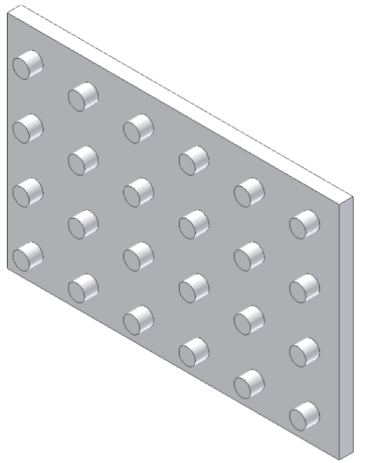

- The rectangular pattern function allows the user to make copies of an existing feature in one direction or two directions simultaneously. Existing edges or the axes of the Cartesian coordinate grid must be selected to identify the desired direction(s). Open the file called Rectangular Pattern. Use the rectangular pattern to copy the existing cylindrical extrusion six times in the horizontal direction and four times in the vertical direction. Save the file as a different name.
CAD file name and location:

- Create the Base Plate for the Button Maker using the dimensioned pictorial below. Create one of the holes in the bottom of the plate into which the rubber feet are screwed. Then use the Rectangular Pattern tool to pattern four holes on the bottom. Next create one of the through drilled (straight) holes and use another rectangular pattern to create the second drilled through hole. Then create the countersink holes. Save the file as BasePlateYourInitials.ipt to your Button Maker roject folder.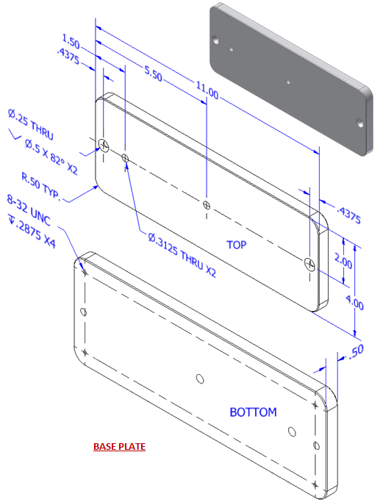

Fillet
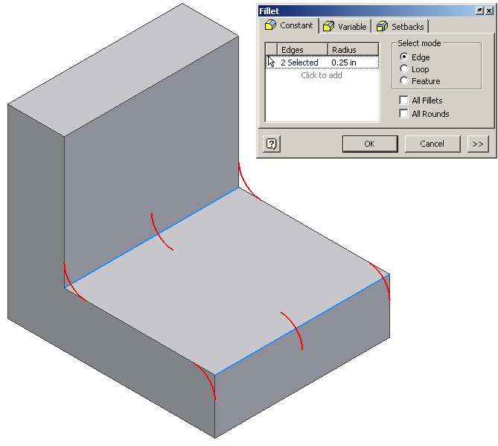
- Fillet is a function that allows the user to create a rounded blend where two surfaces meet to form an edge. It should be noted that on an exterior corner, the resulting feature is known as a round. On an interior corner, the resulting feature is known as a fillet. Open the file called Fillets Chamfers. Use the fillet function to apply a .25 radius to the corners shown above. This model will be used in the next exercise.
- Open the file WindshieldYourInitials.ipt file that you created in Activity 5.2. Fillet the exterior edges of the windshield to a radius of 0.5 inches.

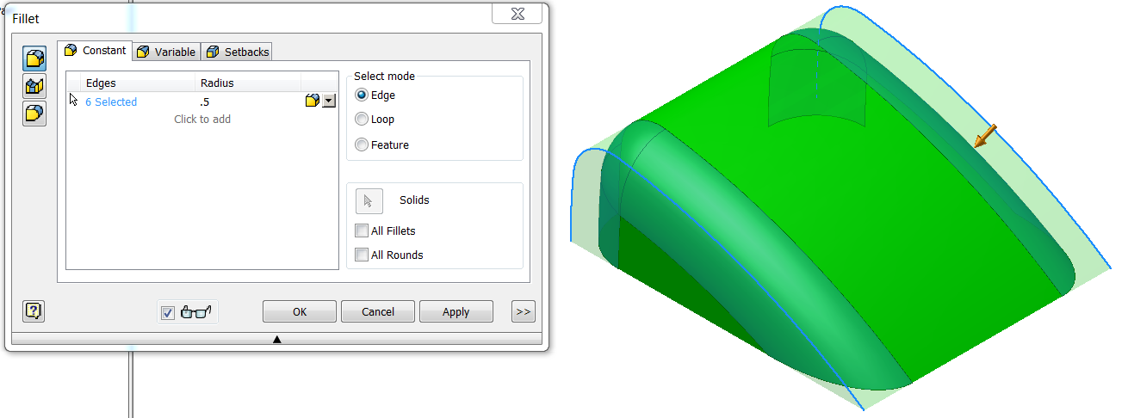

Chamfer
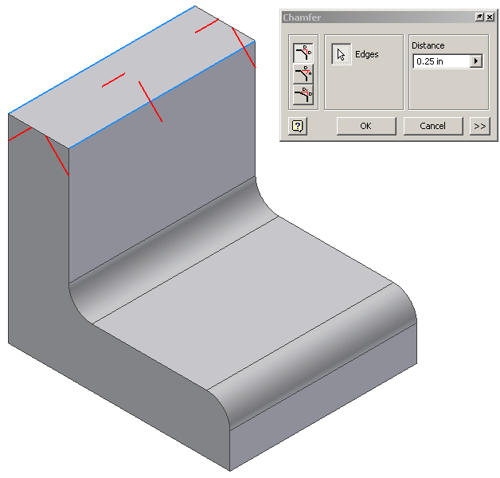

- Chamfer is a function that allows the user to apply an angle surface where two existing surfaces meet to form an edge. Open the file called Rib Support. Use the chamfer function to apply a .25 inch x 45° chamfer to the edges shown above. Save the file as a different name.
CAD file name and location:

- Use the Chamfer function to apply a 1/32” chamfer to all of the edges of the Button Maker Base Plate that you created earlier. Then resave the file to your Button Maker project folder.
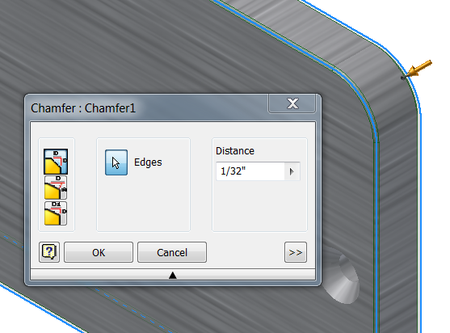

Shell
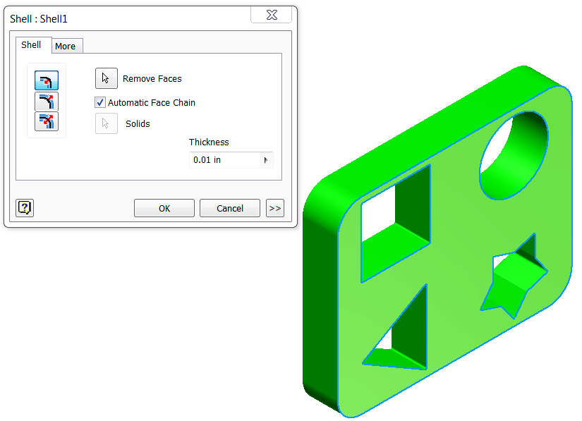 | 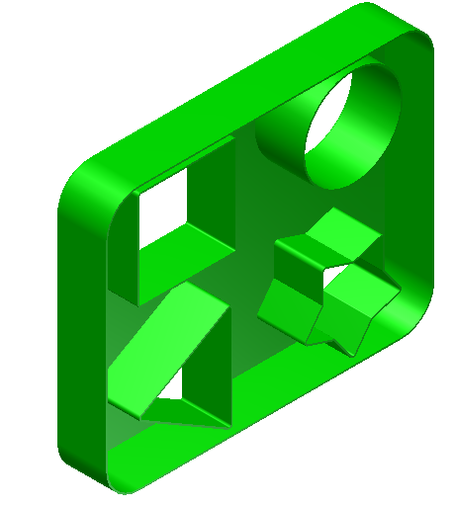
- The Shell function allows the user to remove unnecessary mass from a feature. The resulting geometry will have a wall thickness that is specified by the user. Open PassengerBaseYourInitials.ipt that you created in Activity 5.2. Use the Shell function to remove the excess material to leave a wall thickness of 0.01 inch as shown. Save the file to your Automoblox project folder.
- Open the file WindshieldYourInitials.ipt that you created in Activity 5.2.
  - Rotate the part to view the underside. Shell the enclosure to the measured thickness.
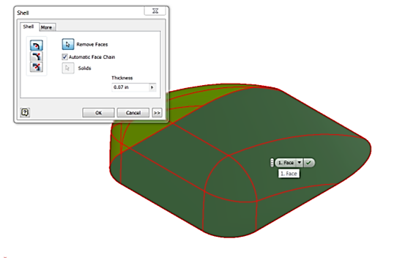 | 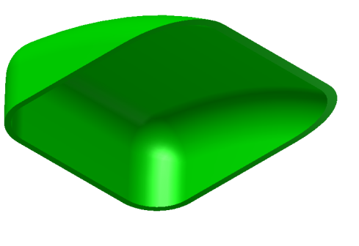
  - Using your measurements or the Automoblox T9 Dimensioned Drawings, create the interior wall of the enclosure that will insert into the vehicle body. You may want to consider the use of an offset work plane and the Shell tool.
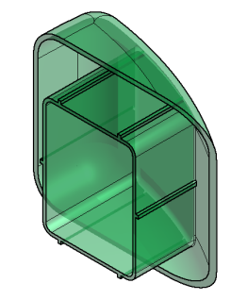
  - Save the completed part file to your Automoblox project folder.
Mirror
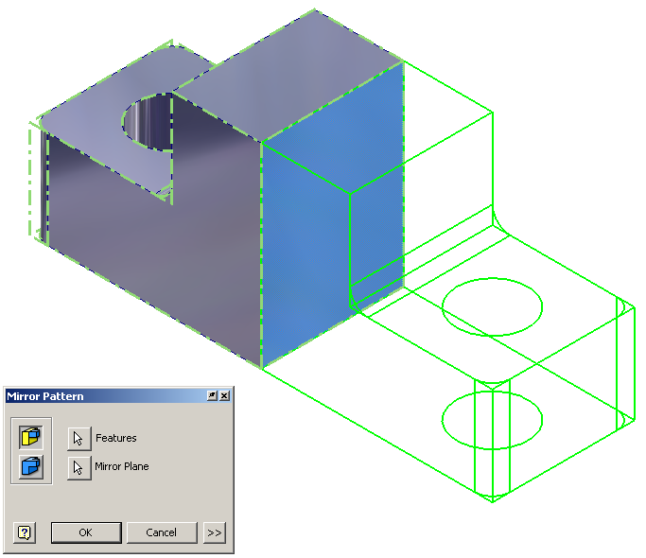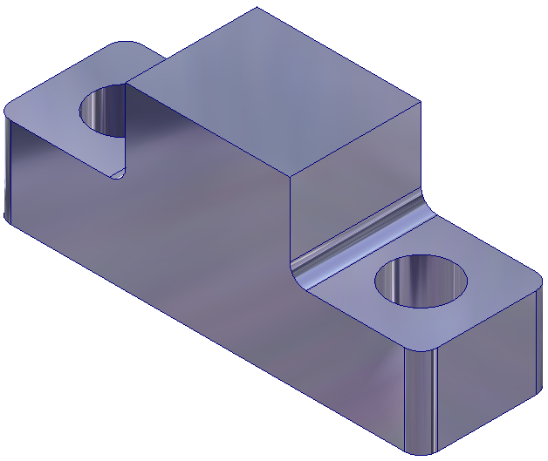

- Mirror is a function that allows the user to create a mirror image of existing geometry. This function requires an existing feature(s) and a surface or work plane to serve as the mid-plane of symmetry. Open the file called Left Half. Use the mirror function to add a duplicate mirror image of the existing geometry on the other side of the right face of the object. Save the file as a different name.

CAD file name and location:

- Create the Bottom Die Plate for the Button Maker by creating half of the part and then mirroring it across the center line. Add the large center hole but do not include the other holes at this time. Save the part as BottomDiePlateYourInitials.ipt to your Button Maker project folder.
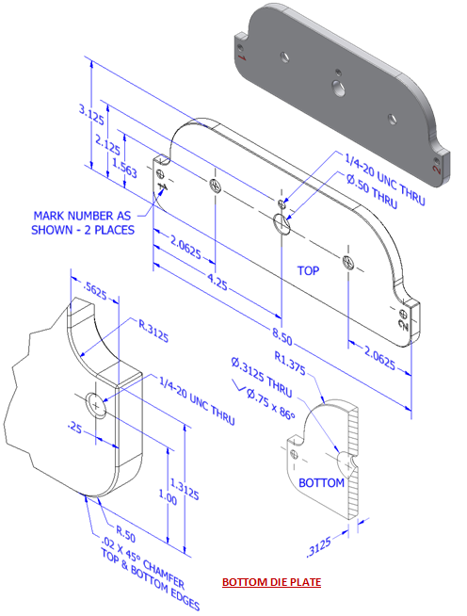

Sweep
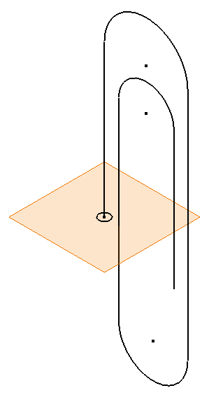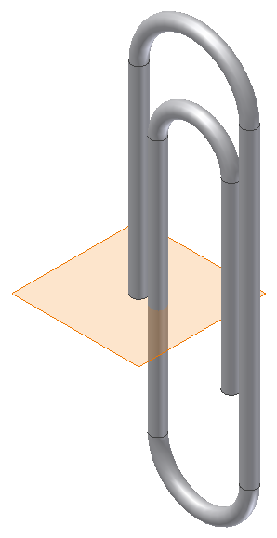

- The sweep function allows the user to extrude a closed profile along a path. The path may be open or closed. The profile and the path must exist as two separate sketches. Open the file called Paper Clip. Use the sweep function to extrude the circle along the existing path to create the form of a paper clip. Save the file as a different name.

CAD file name and location:

Conclusion
- What 3D CAD functions could be used to create a wire coat hanger?

- What feature would be used to create a 3D representation of a spindle that was created on a wood lathe?

- For each of the following, sketch a 2D shape and an axis of rotation that you could use to model each of the following solid forms using the Revolve function within 3D modeling software. Dimension each sketch and indicate the axis of rotation that you would use. You may use software to check your answers.

  - A solid cylinder with a diameter of 3.5 inches and a height of 7 in. Be sure to dimension the shape.

  - A solid sphere using the Revolve function? What rotation angle would you use?

- For each of the following, describe the solid form that would result from rotating the given shape about the axis of rotation by the given rotation angle. Then sketch the resulting 3D shape and indicate important dimensions.
a.
b.

- How does a 3D CAD solid model program display the progression of work involved in creating a model?

- If a mistake is made, how does the user make a correction without using the undo function?

