Activity 5.2 Making Sketches in CAD

Introduction
It would be great if computer systems were advanced enough to take a mental image of an object, such as a sports car, and instantly generate it as a three-dimensional computer aided design (CAD) model on a computer screen. The capability of computers and software is astounding in some respects. For instance, a solid computer model can be created using a 3D scanner to analyze an existing object or space. Likewise, internal body organs and tissue can be “seen” using technology such as Magnetic Resonance Imaging (MRI). Unfortunately, commercially available computer systems have not advanced to the extent that they can document ideas and mental images from the human brain. For now engineers must continue to express ideas as sketches – hand drawn and computer generated.

A CAD model can quickly display an engineer’s ideas in a realistic way. That is, once an engineer has developed a model in CAD representing an idea, the idea can be shared much more easily with a wider audience. As is the case with technical sketching, CAD models must begin as sketches of points, lines, or shapes. The major difference between a freehand sketch and a CAD sketch is accuracy. The lines of a CAD sketch can be drawn perfectly straight, with start and end points that occur in exact locations in space. A line may also be given precise length through the use of dimensions. If more than one line is being sketched, they can be made perfectly parallel or perpendicular. Likewise, they can be given a specific angle. CAD programs give designers the ability to sketch any kind of geometry, along with the ability to dimension, extend, rotate, mirror, copy, pattern, move, trim, or erase it.

The ability to realize CAD models through sequentially developing geometric sketches is a critical skill that designers in multiple engineering disciplines use in the process of converting mental images into money-making products.

Equipment
- Computer with 3D CAD solid modeling program
- CAD files
- Trim Practice
- Move Practice
- Rotate Practice
- Geometric Constraints
- Activity 3.4a Making Linear Measurements (Automoblox PREVIEW) or the Automoblox T9 Dimensioned Drawings.
Procedure
In order to effectively use a CAD program as a design tool, a designer must be familiar with the available and how they work. This activity will help you to understand and utilize the sketching tools that are common to most CAD programs.

Many of the exercises require the creation of a new CAD file and the replication of the images pictured. Other exercises require the manipulation of an already existing file(s). As you finish each exercise, initial the graphic, save the CAD file, document the file name and location on the line provided, and submit this activity to your instructor for evaluation.

Fillet

- The Fillet tool creates a round where two lines meet at a corner. The size of the round is identified as a radius value. Create a new CAD file and draw a rectangle that is approximately 2 inches wide by 1.25 inches tall. Use the Fillet sketch tool to round off the top right to 0.25 inch radius. Then, round off the bottom right corner with a .75 inch radius. Lastly, round off the bottom left hand corner with a 0.5 inch radius.
CAD file name and location:
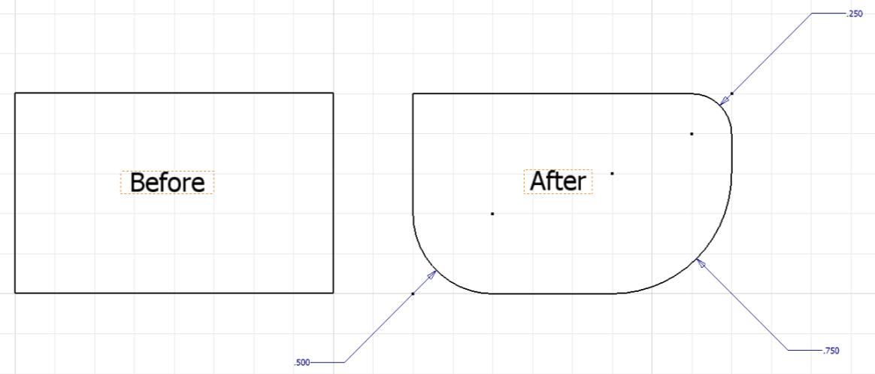

- Model the passenger section of the body of your Automoblox vehicle (using the measurements you recorded in Activity 3.4a Making Linear Measurements (Automoblox PREVIEW) or the Automoblox T9 Dimensioned Drawings.
  - Begin by sketching a rectangle and then filleting the corners before extruding.
  - Next select the top of the body part, create a new sketch and then draw and locate a rectangle with filleted corners to represent the hole based on the appropriate measurements. Save the sketch.
  - Extrude a cut of the shape to the appropriate distance.
  - In the same way make appropriate extrude-cuts in the two opposing faces of the body to allow for the connector socket parts.
  - Save the file as PassengerSectionYourInitials.ipt in your Automoblox project folder.
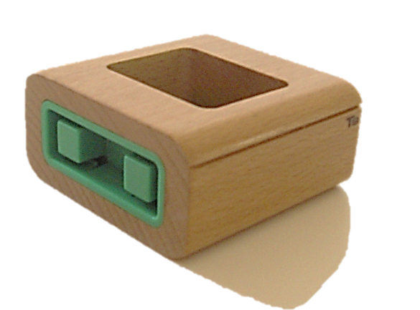  Connector Socket  BODY | 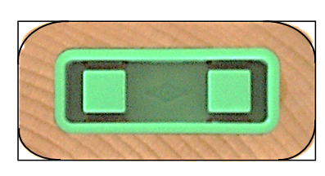  Begin by sketching a rectangle and then filleting the corners.

Trim

- Open the file called Trim Practice. Use the Trim sketch tool and Delete keyboard function to revise the sketch to look like the After image. Save the file as a different name.

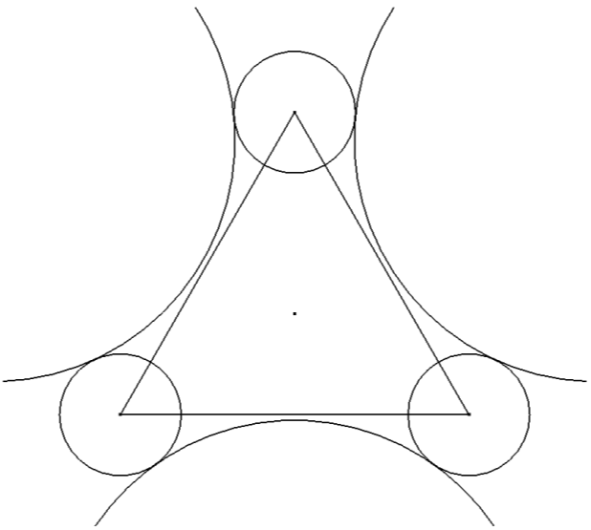 Before | 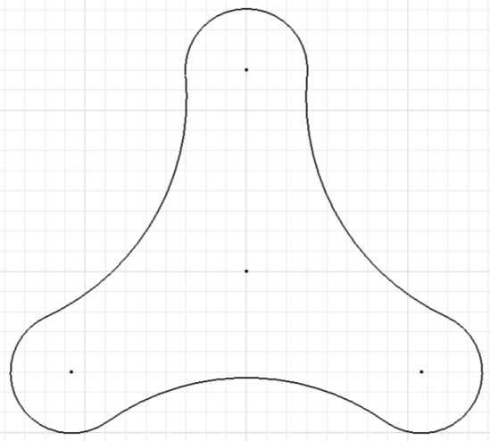  After

CAD file name and location:

Extend

- Create a new CAD and use the Spline and Line sketch tools to replicate the sketch shown below on the left. Use the Extend sketch tool to extend the straight lines to the spline. When finished, the sketch should look like the after image. Save the file and record the file name and location below.
CAD file name and location:

Before | 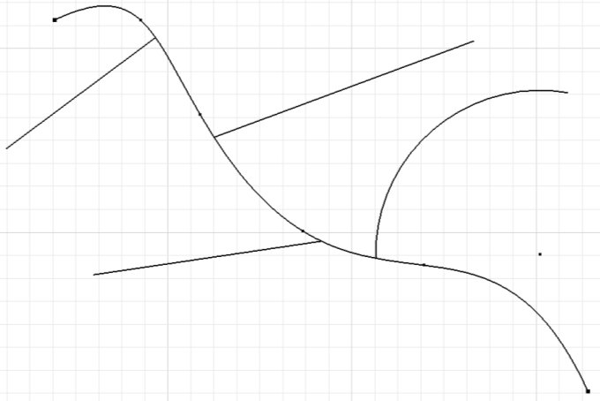  After

Circle and Ellipse

- Create a new CAD file and use the Circle and Ellipse sketch tools to replicate the figures shown below. Label the images as shown using the Text tool. Note that you will need to use the Line tool to first create straight lines in order to create the tangent circle.
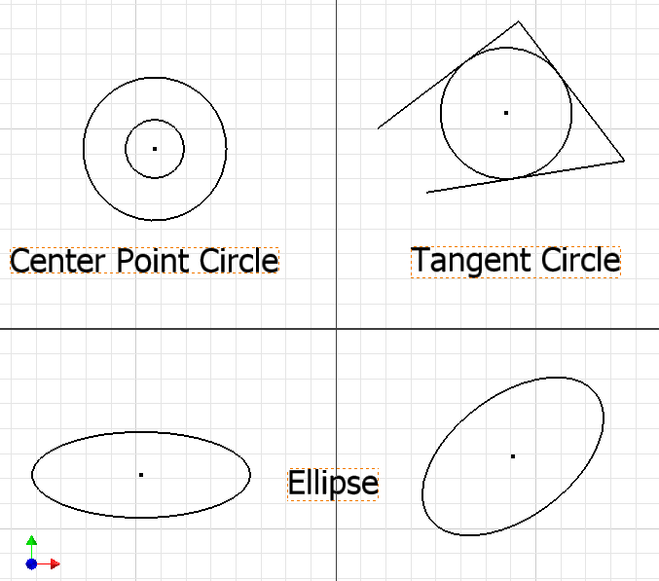

CAD file name and location:

Spline

- The Spline tool is used to create irregular curves, such as the involute curve on a gear tooth or the contour of a car body surface. Create a new CAD file and use the Spline sketch tool to draw two irregular curves and two closed shapes that approximate the figures pictured above. Note the locations and number of points in each spline. Save the file and record the file name and location below.
CAD file name and location:

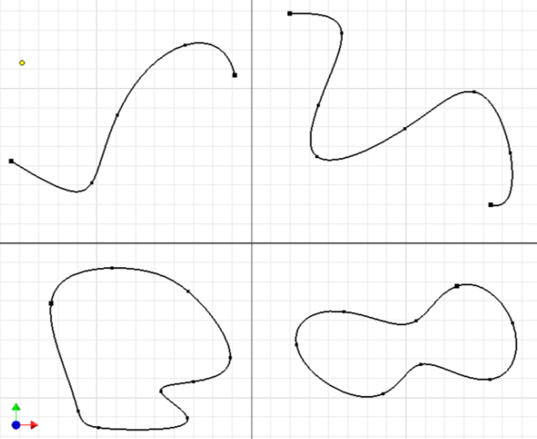

Arc

- Many CAD programs give the user the ability to define arcs through several methods. These methods may include: defining the size of an arc by establishing three points of tangency, referencing two points of tangency, or identifying a center point and two points of tangency. Create a new CAD file and use the Arc sketch tool to replicate the figures shown below. Note that you will first need to sketch two straight lines in order to create the tangent arc. Label the images as shown using the Text tool.
CAD file name and location:

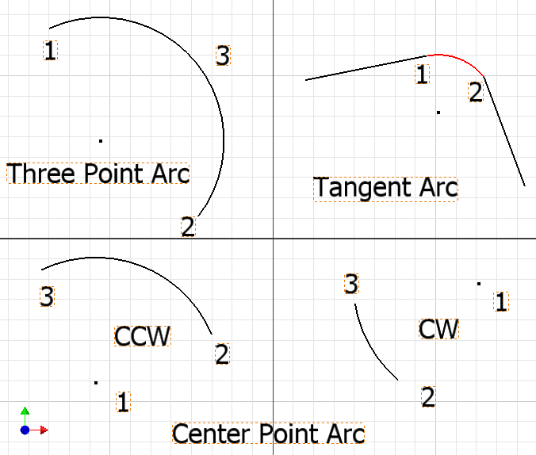

- Begin to create a 3D solid model of the windshield of the Automoblox vehicle by first creating a sketch using the Line and Arc tools. Dimensions for the sketch of the T9 Automoblox windshield are given below. Extrude the part the measured width of the enclosure or according to the pictorial drawing. You will have a “blockish” representation of the top portion only of the enclosure as shown below. You will complete the model in a later activity. Save the file to your Automoblox project folder as WindshieldYourInitials.ipt.
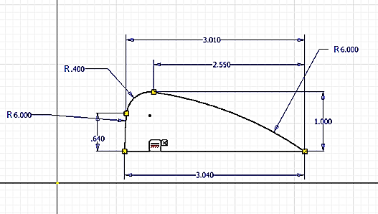
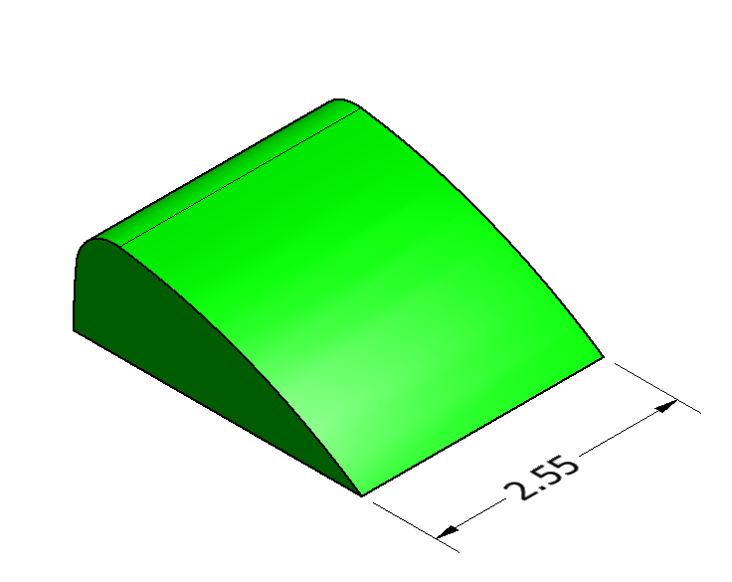
Completed “blockish” extrusion of windshield

Hint: The top of the windshield is sketched using a series of three arcs. Place the horizontal line first. Then you may find it easier to sketch the two arcs with the 6 in. radius (using a three point arc to an approximate size), locate each endpoint with vertical and horizontal dimensions, and then dimension the radii of those two arcs. Finally place and dimension the .4 in. arc last.
Geometric Constraints

- Open the file called Geometric Constraints. Read the directions and use the Geometric Constraint tools to complete each of the 12 exercises. Your completed sheet should look similar to the sheet pictured. Make the geometric constraints visible and add your name to the bottom right corner of the sheet. Save the file as a different name, print it out, and submit it along with this activity to your instructor for evaluation.
CAD file name and location:

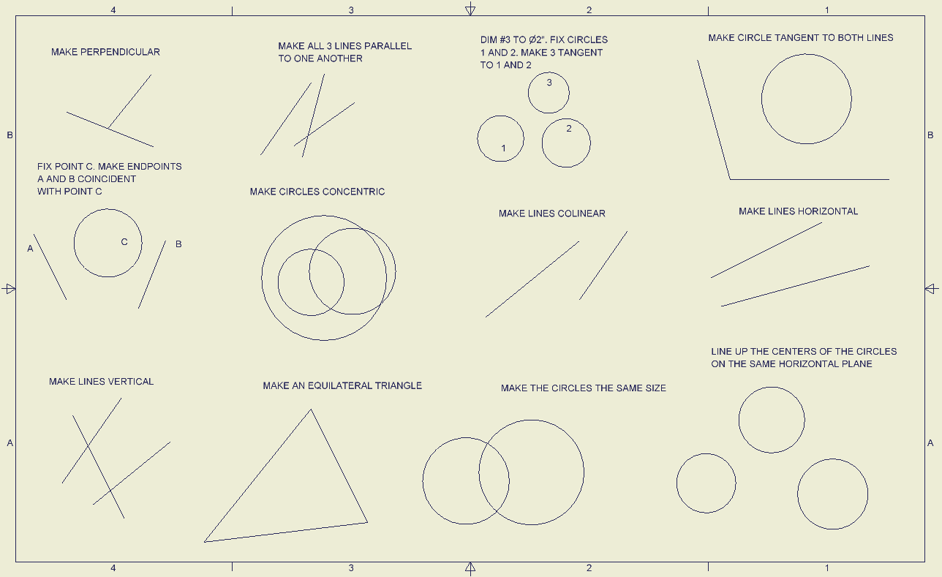
Before
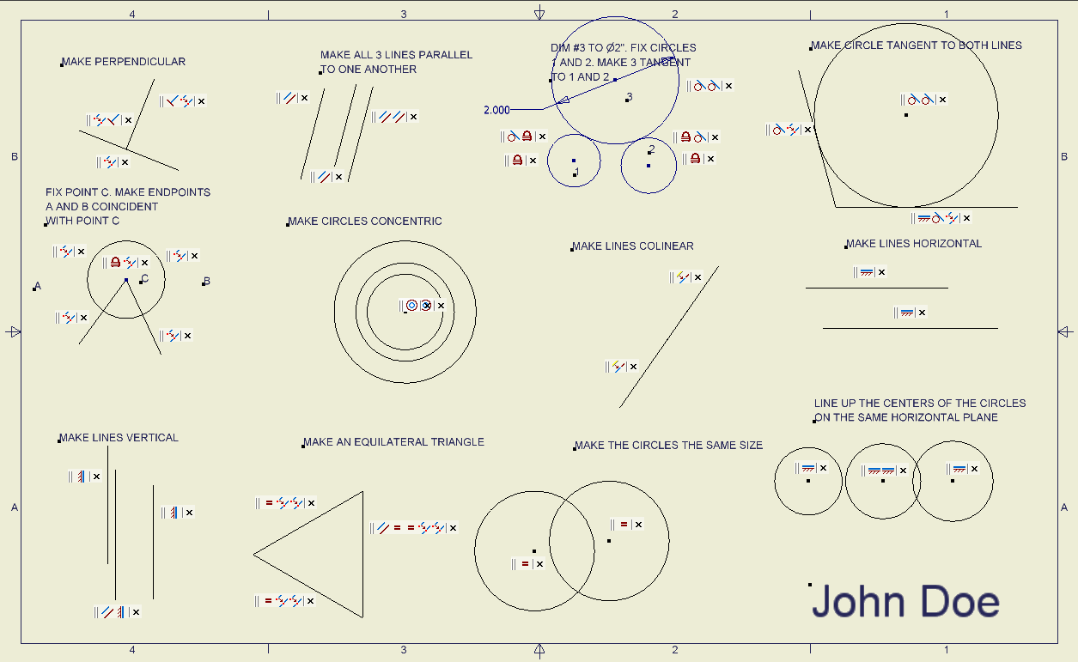
After
- Open WindshieldYourInitials.ipt. Edit the sketch to remove the dimensional constraints on the upper coincident point between the two arcs and add geometric tangent constraints between each pair of adjacent arcs as shown below. Note that if these arcs are not tangent you will not be able to later filet the edge.

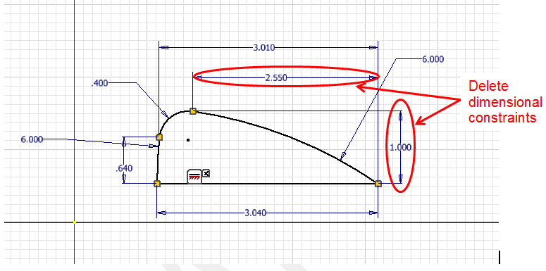
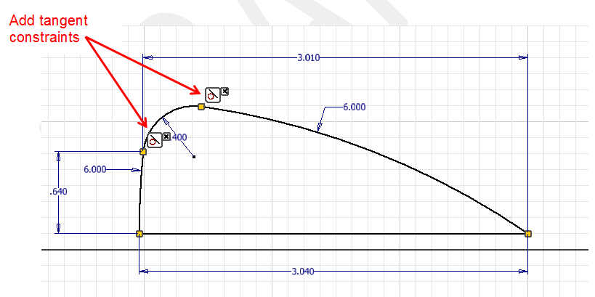

Helpful Hint: To remove a constraint, display the constraint in the sketch, select the constraint to remove and depress the delete key (or right click and select delete).

Move

- Open the file called Move Practice. Use the Move sketch tool to move the geometric shapes to the positions shown in the after image. Save the file as a different name.

CAD file name and location:

Before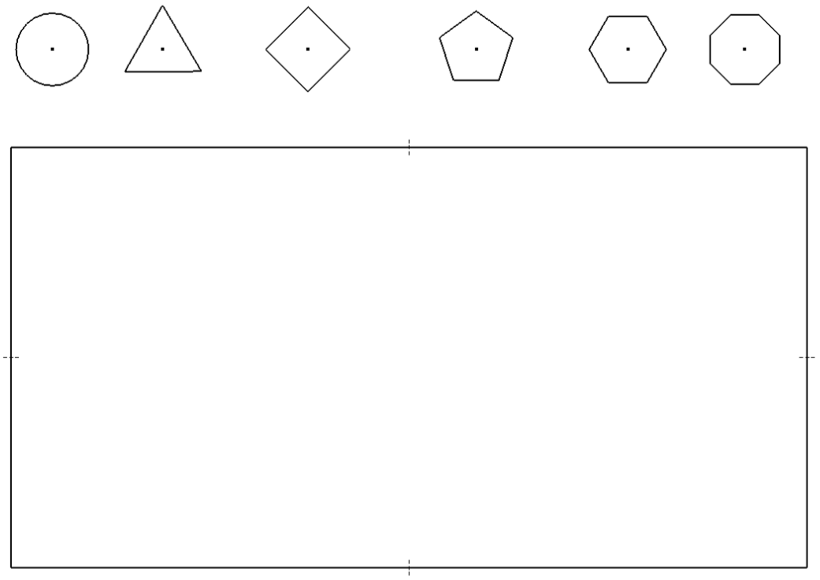

After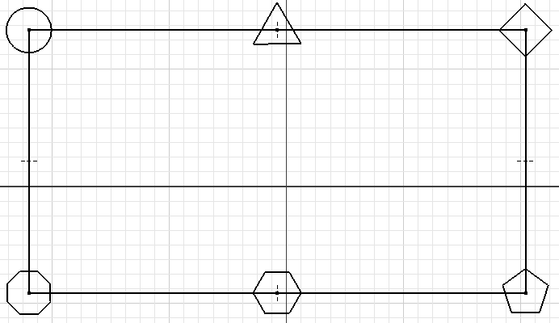

Rotate

- Open the file called Rotate Practice. Use the Rotate sketch tool to rotate the shape shown in the before image to look like the after image. Save the file as a different name.

CAD file name and location:

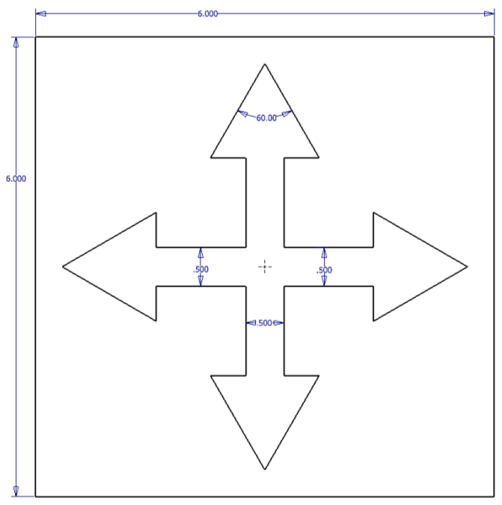  Before | 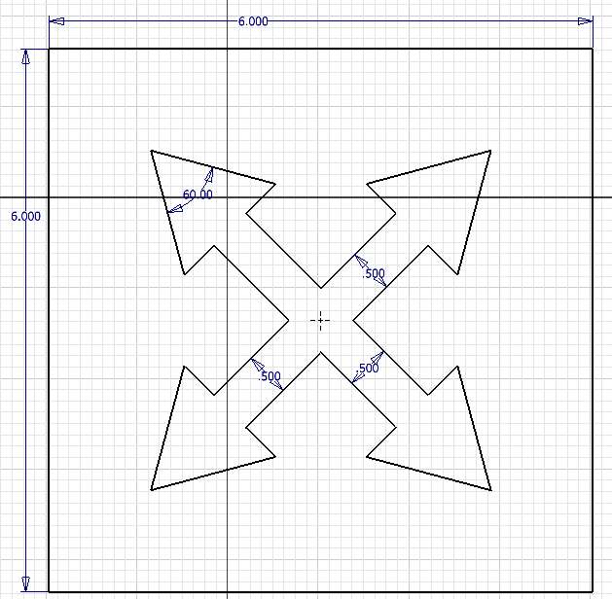 After

Regular Polygons

- Regular polygons are multi-sided shapes that have sides of equal length. They may be inscribed or circumscribed within a given radius. The raw materials that are used to produce engineered objects are often manufactured in the shape of regular polygons. Create a new CAD file and use the Polygon sketch tool to draw the series of shapes pictured below. Use the text tool to identify the shape with a label for each of the regular polygons
CAD file name and location:

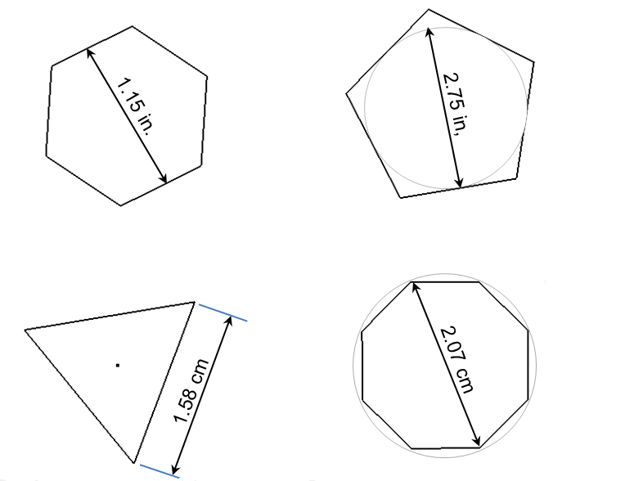

- Use the circle tool and the polygon tool to create a 3D solid model of the passenger base insert for your Automoblox vehicle. Use the measurements you recorded in Activity 3.4a Making Linear Measurements (Automoblox PREVIEW) or the following measurements. Although the part is actually a thin shell, for now your model will be solid. Save the part file as PassengerBaseYourInitials.ipt into your Automoblox project folder.
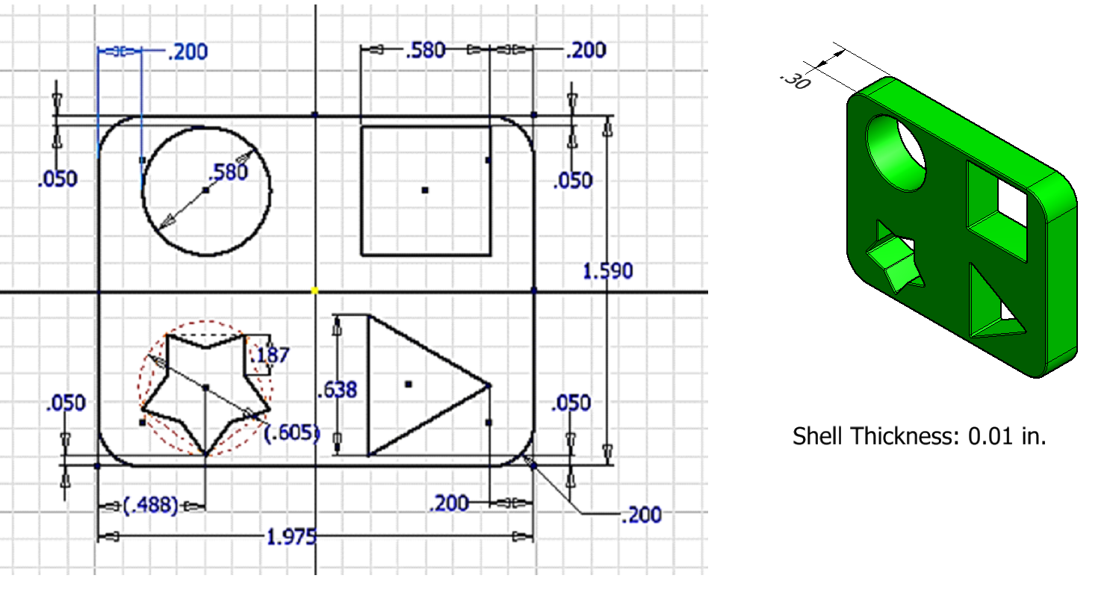
Helpful Hint: To remove a constraint, display the constraint in the sketch, select the constraint to remove and depress the delete key (or right click and select delete).

Hint: To accurately create a star, sketch an inscribed pentagon. Then use the line tool to create the legs of the star in approximately the correct location. Use equal constraints to ensure that the lines used to create the star “legs” are of equal length. You may need to delete extraneous constraints that were automatically assigned while sketching the star in order to apply the equal constraints.

Mirror

- CAD programs allow the designer to mirror images across lines, which is a useful tool when designing parts that have high degrees of symmetry. Create a new CAD file and use the line and circle sketch tools to create a similar figure to the one shown in the Before image below. A regular vertical line may be used as the mirror line. The top and bottom horizontal edges must terminate at the vertical mirror line. Use the Mirror sketch tool to mirror the figure across the mirror line.
CAD file name and location: | ___________________________________

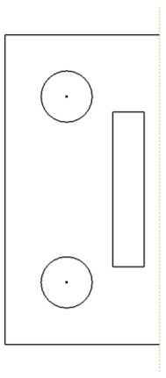Before | 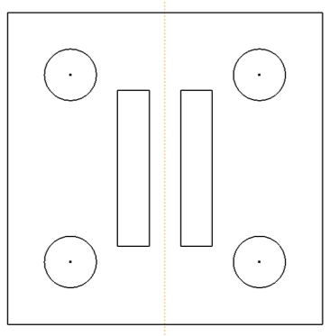  After

- Use lines, fillets and the Mirror tool to create a sketch for the removable connector piece for the Automoblox. Using your measurements or the Automoblox T9 Dimensioned Drawings, sketch the outline profile for one quarter of the face that includes the long rectangle as shown below. Do not sketch the rectangular hole. Mirror the sketch twice before extruding the sketch the measured distance. Screen captures of the sketching process are shown below. Save the file as ConnectorYourInitials.ipt.
Note that if you have trouble extruding the sketch, you may need to use the Trim tool or Close Loop feature within the sketch to create coincident endpoints between adjacent lines and arcs. To close an open sketch loop, right click on a line and choose close loop, then follow the instructions.
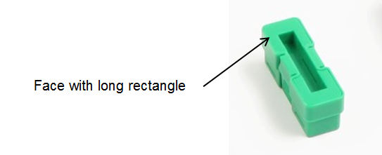
- Sketch one quarter of the outline profile of the connector piece.
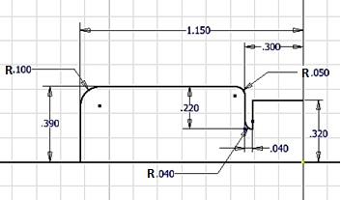

- Mirror the sketch to create half of the profile.
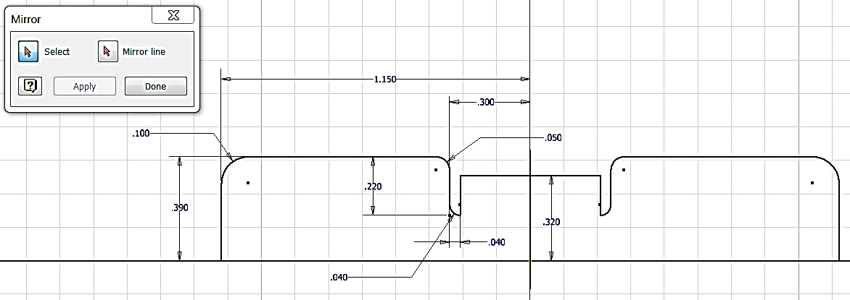
- Mirror a second time to complete the profile.
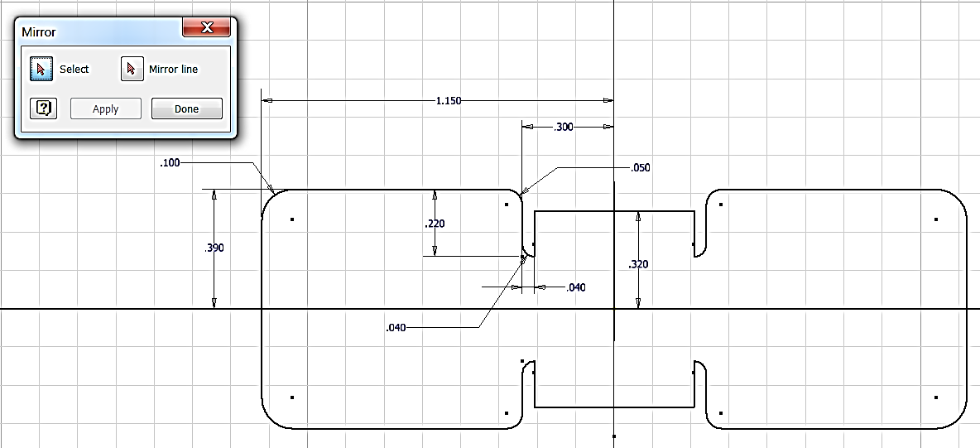
- The connector will resemble this part.
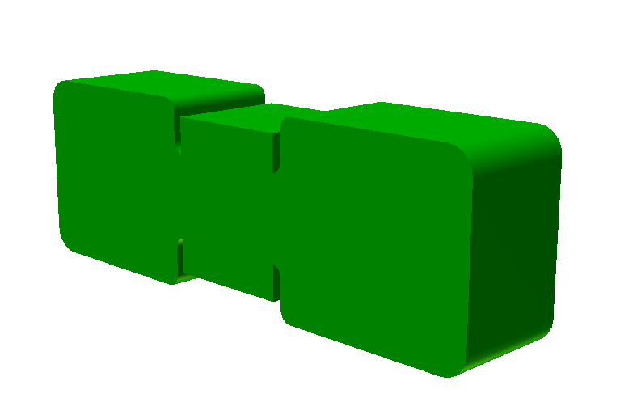

Offset

- The need to create geometry that is identical in shape and parallel is very common in engineering design. The Offset sketch tool is used to make this process quick and accurate. Create a new CAD file and draw the figures pictured in the Before image. Use the Offset sketch tool to offset the geometry of each figure outward two times such that the sketch resembles the After image.
CAD file name and location:

Before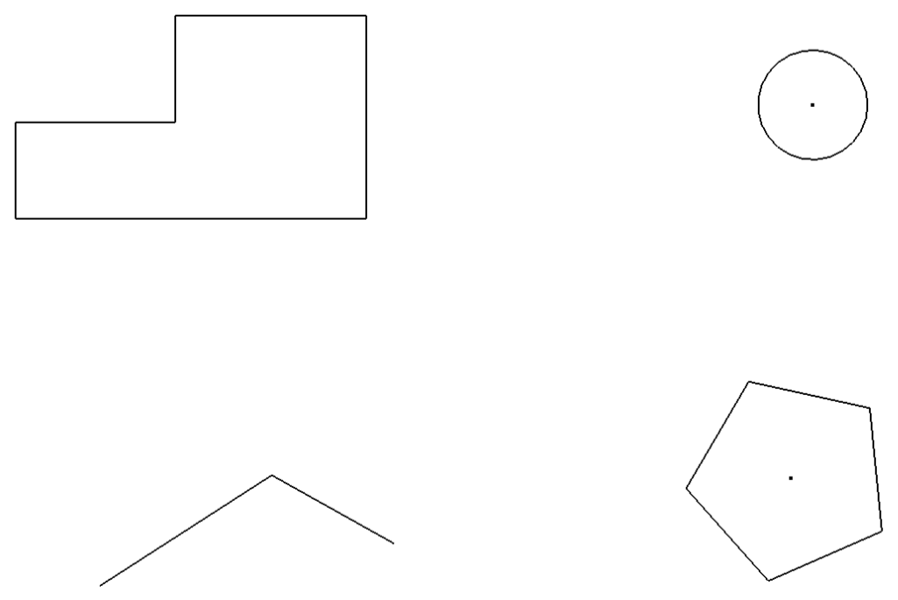

After 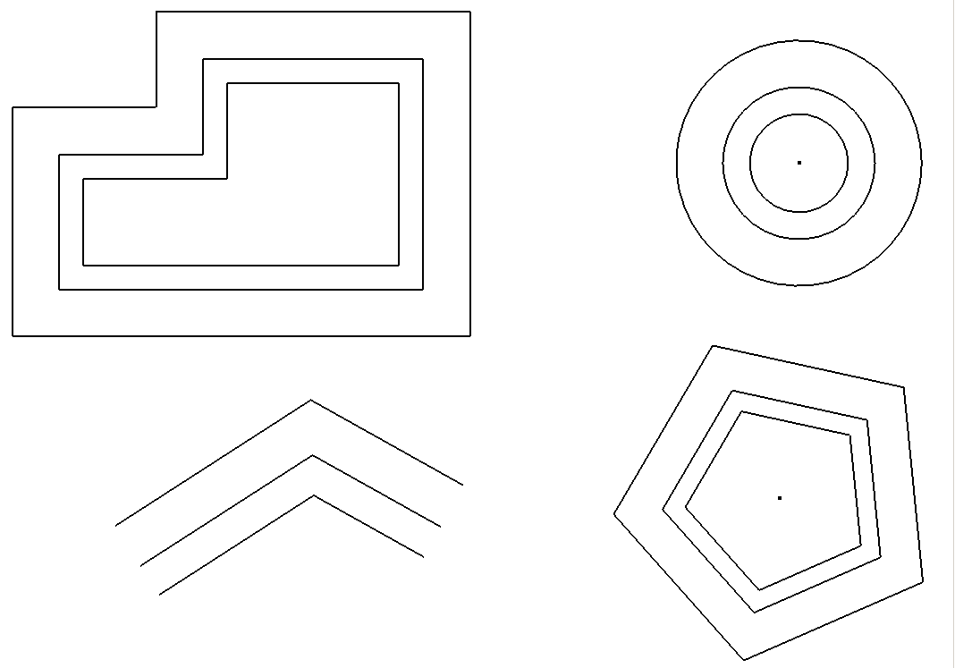

Circular Pattern

- The ability to pattern a shape or element allows the designer to save time and maintain accuracy. Create a new CAD file and draw a circle with a diameter of approximately 2.25 inches. Use the polygon sketch tool to create an isosceles triangle that would fit within a .25 inch diameter circle. Orient the triangle so that it is pointing toward the top quadrant of the circle. The center of the triangle should be approximately 7/8 inch from the center of the circle. Use the Pattern sketch tool to create a copy of the triangle 12 times (the number of instances includes the object being patterned) around the center of the circle.
CAD file name and location:

Before  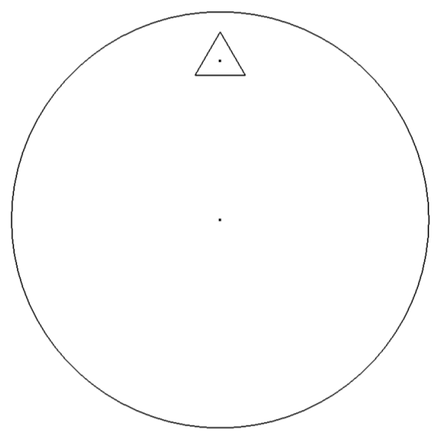 | After  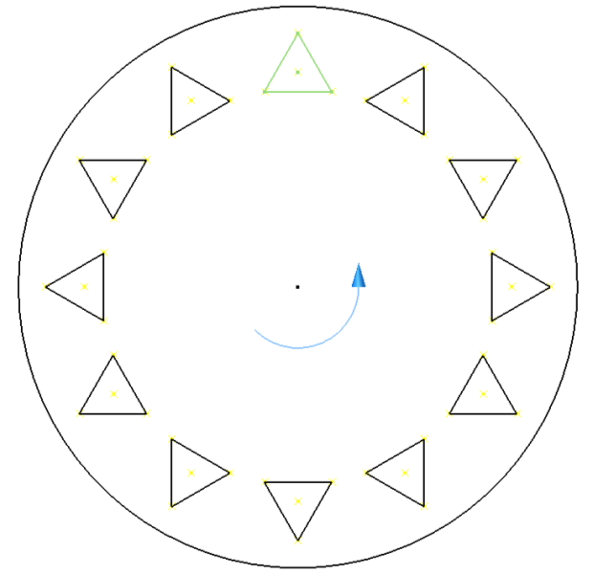

- Create a simplified 3D model of the wheel for the Automoblox vehicle. This model will not replicate the actual wheel exactly. Once you have gained more familiarity with Inventor tools and features, you may want to try to more closely mimic the contours of the wheel. Suggested steps to creating the wheel are given below. When finished, save the file as WheelYourInitials.ipt.
a. Create the inner and outer walls. Use offset circles (2 pair) to create the inner and outer walls per the measurements shown (or use your own measurements of the wheel).
 |  |  | 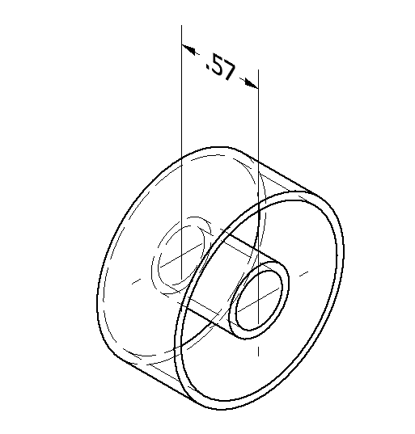
b. Create the face of the wheel. Create a new sketch on a flat face and use the Project Geometry sketch tool to transfer the geometry of the inner and outer walls to the sketch plane. Use a Mid-plane Extrusion to extrude the ring a distance of .050 inches to create the face. Note that you need to include the area of the inner wall in the extrusion.
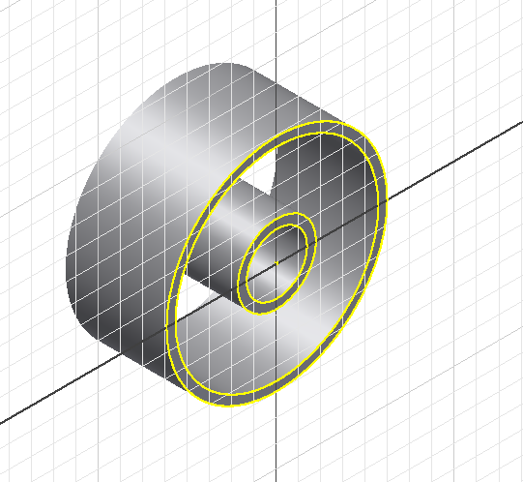 | 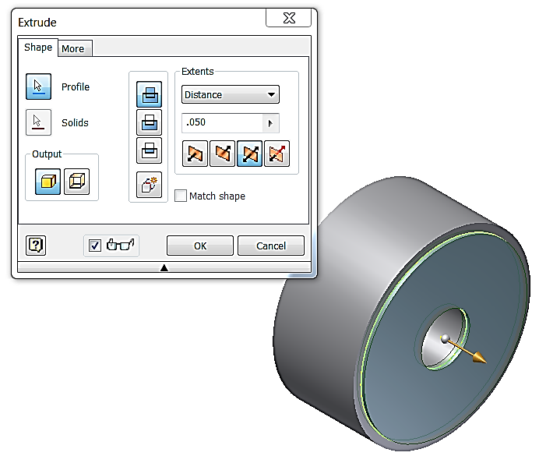
c. Create the face pattern. Place a new sketch on the exterior face of the wheel and sketch a closed loop to mimic the semicircular cutout shape of one opeing in the wheel face. You may use the Circle and Trim tools to create this shape. Then use a circular pattern to create the remiaing openings in the wheel face. Use your measurements or the dimension shown below for the T9 wheel.
 |  | 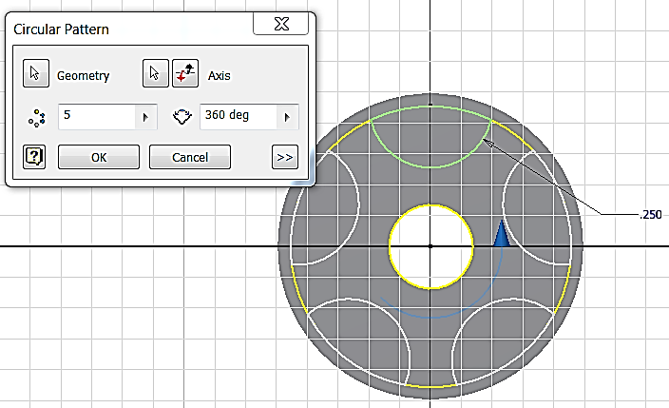

d. Cut the face pattern. Extrude – Cut the semicircular shapes to create the face pattern.
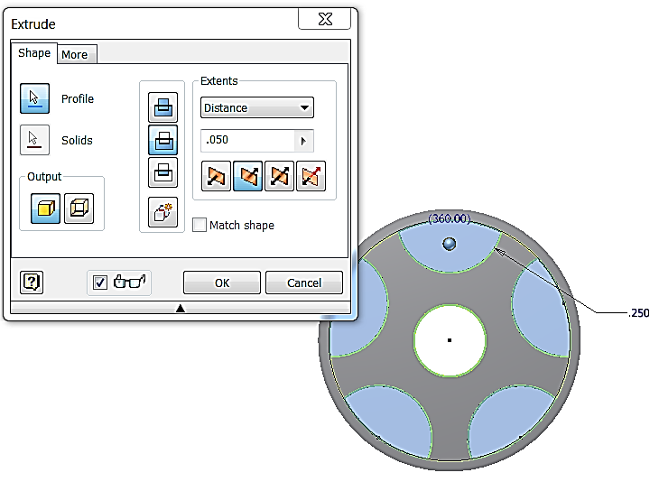 | 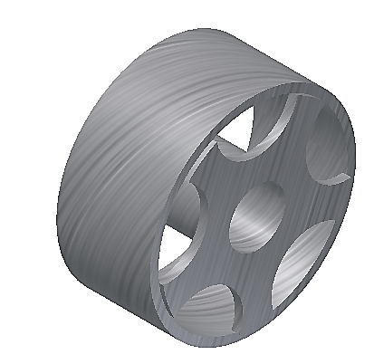  Finished (simplified) Model

Rectangular Pattern

- The Pattern sketch tool allows the designer to create a pattern from one or several objects. The direction or orientation of the pattern is derived from existing lines on the sketch. Create a new CAD file and draw a rectangle that is approximately 4 inches wide by 3.25 inches tall. Create a 3/8 inch diameter circle in the lower left hand corner. Locate the center of the circle approximately 3/8 inch from the bottom and left edges. Use the Pattern sketch tool to create multiple copies of the circle. The rectangular pattern must have seven columns and six rows, and must fit within the boundaries of the rectangle.
Before | After
CAD file name and location:

Text and Emboss

- Open PassengerSectionYourInitials.ipt. Use the Text tool to write the model name in a sketch located to mimic the location of the model name on the toy vehicle. Use the Emboss feature to emboss the model name to a depth of 0.02 inches into the part. Then “paint” the raised letters/numbers by selecting the surface of all letter/numbers, right clicking, selecting Properties in the drop down menu and then changing the face color to black.
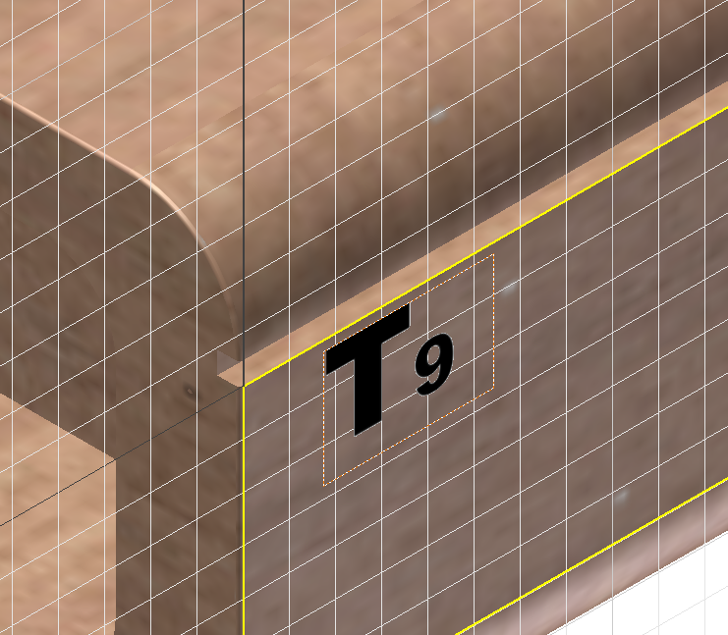  1. Create a sketch and use the Text tool to write the name of the Automoblox model. Place the sketch in the appropriate location on the vehicle. | 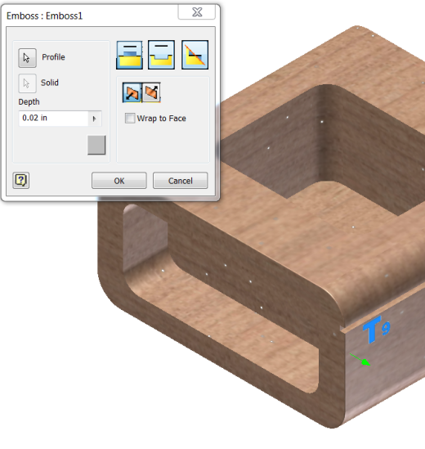  2. Use the Emboss features to create raised letters. Use a depth of 0.02 inches.
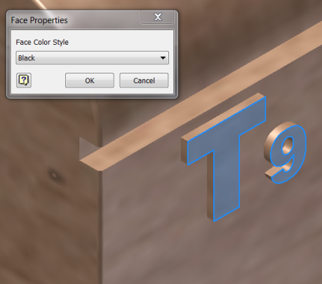  3. “Paint” the surface of the embossed letters by changing the face color style of the surface. Select the surfaces of the letters, right click, select Properties and then choose Black from the list of colors. | 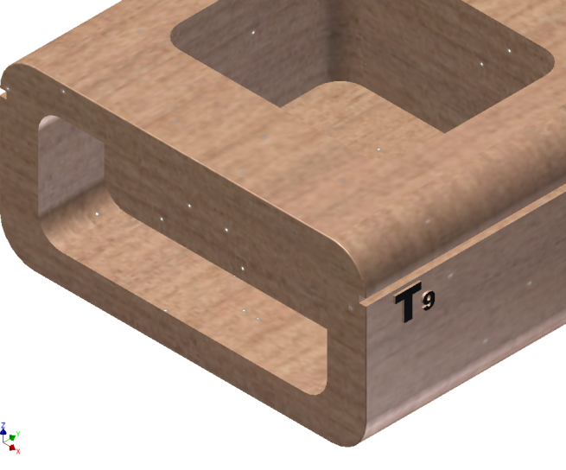  4. Finished letters.

Conclusion

- What is a geometric constraint?

- What are the different types of geometric constraints that are applied to sketches, and what are their functions?

- Review the After image in number 20 above and answer each of the following.
  - Describe the angle formed between the two lines in the MAKE PERPENDICULAR exercise. What is the angle measure?

  - Describe the angle formed between the two lines in the MAKE COLINEAR exercise. What is the angle measure?

What type of angle is shown in the image to the left? Define this type of angle.
What type (in terms of interior angle measure) of triangle is shown in the image to the left? How do you know?
- Define “tangent”.

  - Sketch a line tangent to two circles.

  - Sketch three circles such that all circles are tangent to the other two.

- How is a geometric constraint different from a numeric constraint?

- What types of numeric constraints may be applied to sketches?

- What advantages do CAD sketches have over freehand sketches?

- What disadvantages do CAD sketches have when compared to freehand sketches?

